User Manual: Purchasing

| May-20 |

**Document Overview**

**Documentation Goals**

This documentation is intended to provide instruction for all ***Purchasing*** functions*.* It details the use of ***Creating and Editing Purchase Orders, Closing and Reopening Purchase Orders, Running Purchase Order Reports***, and maintaining the ***Purchasing Master Files***.

**Documentation Disclaimers**

* Teach a user how to utilize the Purchasing system.
* Provide instructions for overseeing the creation and maintenance of purchase orders.

**Table of Contents**

**Overview of Advantzware Specific Keys and Icons** 4

Function Keys 4

Advanced Software Standard Function Keys 5

Program Icons 6

**Purchasing Overview** 7

**Update / Enter Purchase Orders [PU]** 8

Enter / Edit Purchase Orders [PU1] 8

Overview 8

Browse PO 8

View PO 10

Add/Update PO 11

Items 14

Add/Update Item Field Definitions 16

Scores: Update Panel Sizes 18

Box Design 18

Purchase Order Notes 19

Group Notes on PO 19

SPEC Item Notes on PO 19

Print PO Edit List [PU2] 20

Print Purchase Orders [PU3] 22

Close / Reopen Purchase Orders [PU4] 25

Browse PO 25

View PO 27

Items 28

View Detailed Item 29

**Query Purchase Orders [PQ]** 30

PO Inquiry [PQ1] 30

Browse PO 30

View PO 32

Invoices 33

Receipts 34

**Reports for Purchasing [PR]** 35

Sheets on Order [PR1] 35

Scheduled Reports [PR2] 38

PO FG/RM History [PR3] 41

Material Required for Job [PR4] 44

PO Purchased Variance [PR5] 47

PO Vendor Analysis [PR6] 50

PO Receipts Not Vouchered [PR7] 53

Shipment Approval Report [PR8] 56

PO FG/RM History by Custom [PR9] 58

Receipts Overages for Credit [PR)] 61

PO’s Vouchered by FG Category [PR!] 63

Bill of Materials Print [PR@] 66

Board / Paper To Order [PR#] 67

Scheduled Receipts with Orders [PR$] 70

**File Maintenance for Purchases [PF]** 73

PO Rejection Codes [PF1] 73

Browse Reason 73

View Reason 74

Purchase Orders Control Menu [PF2] 76

P/O Control 76

Update P/O Control 76

Vendor Cost Matrix [PF3] 77

Browse Vendor Cost Matrix 77

Vendor Cost 79

Vendor Cost Levels 82

Add/Update Vendor Cost Levels 83

Add/Update Multiple Cost Levels 83

Vendor Restrictions 85

Update Vendor Restrictions 85

**Purchase Order / Receipt Logic for Outside Sheeting** 87

Example 87

# **Overview of Advantzware Specific Keys and Icons**

## Function Keys

|  |  |
| --- | --- |
| BRWS | The browser, which is a list of records in this file. This is functionally equivalent to the Find option of our standard package. |
| VIEW | View record provides the ability to ADD, CHANGE, DELETE, and UPDATE an individual record. |
| SORT BY | The selections at the bottom of the browser, which will sort the list alphabetic order. |
|  |  |
| Update | Update the current record. |
| Reset | Reset the current record. |
| Add | Add a record. |
| Copy | This will copy the existing record. |
| Delete | Delete the current record displayed on the screen. |
| Cancel | Cancel the information that was entered. |
| Save | Save the record. |
|  |  |
|  | Takes the user to the first current record. |
|  | Moves backward one record. |
|  | Moves forward one record. |
|  | Takes the user to the last current record. |
|  |  |
| F1 | Miscellaneous Fields |
| F3 | Search |
| F3 | List |
| F4 | Notes |
| F6 | Browse |
| F7 | Viewer |
| F12 | Exit |

## Advanced Software Standard Function Keys

|  |  |
| --- | --- |
| Next | Shows the next sequential record. |
| Prev | Shows the previous record. |
| Add | Add a record. |
| Change | Change the current record displayed on the screen. |
| Delete | Delete the current record displayed on the screen. |
| Find | Find a record by searching by description. |
| “1”, “2” | Number 1 or 2 to go the first or second page of this record. |
| Esc | Escape from the current transaction without updating. |
| Q | Quit from the current transaction without updating. |
| F1 | Save |
| F3 | Help information is available on every data field. Simply place the cursor on a field and press F3 to display documentation regarding this particular field. |
| F3 | To insert additional data in a data field without erasing the information currently displayed. |
| F4 | Notes – General |
| F1 | Field Lookup is available on every data field which is maintained in a separate file. Place the cursor on a field and press ***“F1”*** to search for the code by description or to advance a screen of records by pressing the next key. Place the cursor next to the desired record and press enter to transfer the record to the data entry screen. See ***“Page Up”*** / ***“Page Down”*** keys below as an alternative |
| F7 | Delete |
| F8 | Notes – File Specific |
| Enter | Advances the cursor to the next field |
| Page Up | Will skim forward through each record in a data file in sequential order |
| Page Down | Will skim backward through each record in a data file in sequential order |
|  |  |

## Program Icons

|  |  |  |
| --- | --- | --- |
|  | Job Notes |  |
|  | Customer Attachments | Attach files (such as Word/Excel/Images) for this specific customer order. |
|  | Change Move/Set Column Mode |  |
|  | Print Acknowledgement |  |
|  | Export to Excel |  |
|  | Add |  |
|  | Attachments | Attachments for this Estimate. Will transfer to all future repeat orders for this estimate. |
|  | Notes |  |
|  | Spec Notes | Notes for specific finished goods items. |
|  | Utility Application |  |
|  | Help |  |
|  | UDF Viewer |  |
|  | Commissions |  |
|  | Exit |  |
|  |  |  |
|  |  |  |

# **Purchasing Overview**

The purpose of a purchasing module is to produce purchase orders for vendors for raw materials and finished goods items. Finished goods items may be drop shipped directly to your customer or delivered to your plant for later shipment to your customer. The same is true for raw materials. However, most often, raw materials are purchased for delivery to your plant for use in your manufacturing process.

Prior to utilizing the purchasing module, the raw materials items and finished goods items if purchasing supplies as well as the Accounts Payables file must first be defined. For each item of raw material or finished goods, general ledger asset accounts must first be defined.

For raw materials items, the material cost type file provides defining the inventory asset account. This material cost type must be defined in the raw material item file. For finished goods items the inventory asset account is defined in the product line file. Multiple product categories may be defined for a product line. The product category must be defined for the finished good item. Once the general ledger accounts are defined, they are automatically transferred to the purchasing module for later transfer to the Accounts Payables system once receipts for the items have been posted.

The initial release of purchasing will not provide an automatic integration to Accounts Payables. Therefore, receipts for goods must be processed through either the finished goods or raw materials modules. Once received, a voucher must be processed through the Accounts Payables module as a second step. In a future release, receipts for purchasing will provide this automatic integration.

When two options for printing purchase orders exist, one option provides printing the order on a pre-printed form which must be purchased by our tri-state graphics form supplier. The second option allows the purchase order to be printed on plain paper with Advanced Software's headings pre-defined. The second option, although not as graphically aesthetic, provides the ability to transfer purchase orders via EDI without printing the purchasing document.

Other features within the purchasing modules will provide inquiries and reports for scheduled receipts by item and by job as well as by vendor. In addition, vendor analysis reports and cash requirements based on expected deliveries should provide a better picture of cash flow requirements.

# **Update / Enter Purchase Orders [PU]**

## Enter / Edit Purchase Orders [PU1]

### Overview

Many options exist at the bottom of the screen to add, change, delete, or find a purchase order. Once the purchase order is displayed on the screen, the fields on the header screen may be changed or a totals screen may appear by pressing ***"T"***, or you may go to the line items screen by pressing ***"2"*** for screen two.

The find feature provides search access capabilities for numerous fields. Simply press the letter ***"F"***, then tab to the appropriate field you desire to search upon. You may then press ***“F1”*** or type a few characters to limit the search then press ***“F1”*** or ***“Enter”***. ***“Enter”*** will bring up the first record immediately whereas ***“F1”*** will begin a scrolling list which you must then select the purchase order to edit.

### Browse PO

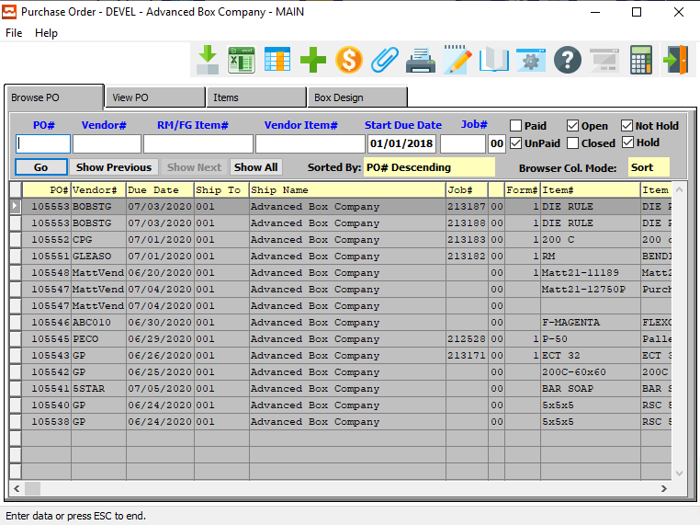

#### ADD

Click the ***“Green + Icon”*** to add a new Purchase Order.

### Browse PO Field Definitions

#### PO #

Enter the PO number for a look-up of a customer or you may use the ***“F1”*** key to find the customer. A partial description may be typed into any field or data may be entered into multiple fields followed by pressing the ***“Go”*** button to sort the fields by the criteria that was entered.

#### Vendor #

Enter the vendor number to look-up your customer or you may use the look-up ***“F1”*** key look-up. A partial description may be typed into any field or data may be entered into multiple fields followed by pressing the ***“Go”*** button to sort the fields by the criteria that was entered.

#### RM/FG Item #

Enter the FG item number or you may use the ***“F1”*** look-up. A partial description may be typed into any field or data may be entered into multiple fields followed by pressing the ***“Go”*** button to sort the fields by the criteria that was entered. Once the data is presented on the screen, the YELLOW column heading may be clicked to sort that specific column in ascending or descending order.

#### Vendor Item #

Enter the vendor item number or press ***“F1”*** to search for a vendor. A partial description may be typed into any field or data may be entered into multiple fields followed by pressing the ***“Go”*** button to sort the fields by the criteria that was entered. Once the data is presented on the screen, the YELLOW column heading may be clicked to sort that specific column in ascending or descending order.

#### Start Due Date

Enter the start due date. A partial description may be typed into any field or data may be entered into multiple fields followed by pressing the ***“Go”*** button to sort the fields by the criteria that was entered. Once the data is presented on the screen, the YELLOW column heading may be clicked to sort that specific column in ascending or descending order.

#### Job #

Enter the job number or you can do a ***“F1”*** look-up from list. A partial description may be typed into any field or data may be entered into multiple fields followed by pressing the ***“Go”*** button to sort the fields by the criteria that was entered. Once the data is presented on the screen, the YELLOW column heading may be clicked to sort that specific column in ascending or descending order.

#### Paid – Toggle Box / Unpaid – Toggle Box

To search for Purchase Orders that have been paid, make sure that the Paid toggle box is checked. To search for Purchase Orders that have not been paid, make sure that the Unpaid toggle box is checked.

#### Open – Toggle Box / Closed – Toggle Box

To search for Purchase Orders that are still open, make sure that the Open toggle box is checked. To search for Purchase Orders that are closed, make sure that the Closed toggle box is checked.

#### Not Hold – Toggle Box / Hold – Toggle Box

To search for Purchase Orders whose status is not on hold, make sure that the Not Hold toggle box is checked. To search for Purchase Orders whose status is on hold, make sure that the Hold toggle box is checked.

### View PO

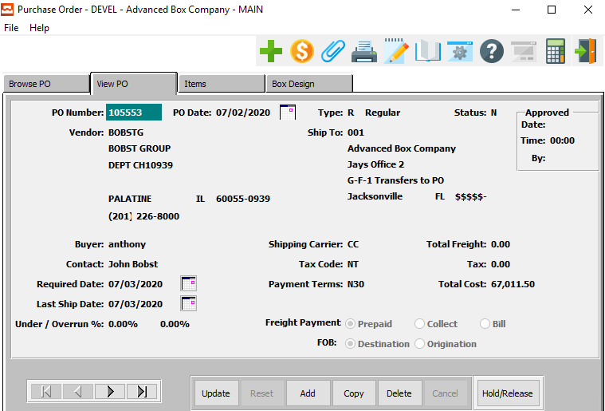

#### UPDATE

To change the currently selected Purchase Order, simply click the ***“Update***” button at the bottom of the screen.

#### ADD

To add a new Purchase Order, simply click the ***“Green + Icon”*** button at the top of the Purchase Order screen.

Alternatively, click the ***“Add”*** button at the bottom of the screen.

#### DELETE

To delete the currently selected Purchase Order, simply press the ***"D"*** key. Alternatively, click the ***“Delete”*** button at the bottom of the screen.

#### NEXT

Press ***"N"*** (Next) to find next Purchase Order to view or modify. Alternatively, press the ***“Right Arrow”*** on the screen.

#### PREVIOUS

Press ***"P"*** (Previous) to find previous Purchase Order to view or modify. Alternatively, press the ***“Left Arrow”*** on the screen.

#### HOLD/RELEASE

Click the ***“Hold/Release”*** button to change the status of the currently selected Purchase Order from “Released” to “On Hold”.

### Add/Update PO

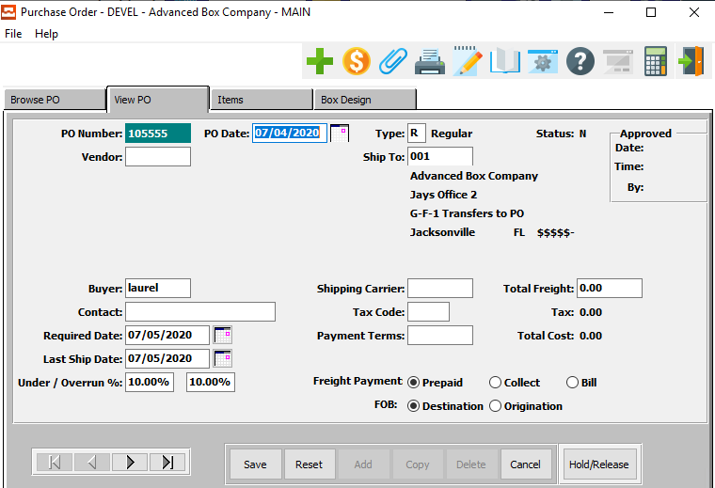

#### SAVE

Click the ***“Save”*** button to save all changes to the current Purchase Order.

#### RESET

Click the ***“Reset”*** button to reset all fields to their original state.

#### CANCEL

Click the ***“Cancel”*** button to cancel all changes to the Purchase Order without saving.

#### NEXT

Press ***"N"*** (Next) to find next Purchase Order to view or modify. Alternatively, press the ***“Right Arrow”*** on the screen.

#### PREVIOUS

Press ***"P"*** (Previous) to find previous Purchase Order to view or modify. Alternatively, press the ***“Left Arrow”*** on the screen.

#### HOLD / RELEASE

Click the ***“Hold/Release”*** button to change the status of the currently selected Purchase Order from “Released” to “On Hold”.

### Add/Update PO Field Definitions

#### PO Number

The Purchase Order Number Field transfers automatically from the PO control file and is incremented by 1 as each purchase order is added.

#### Vendor

The Vendor code defaults from the Accounts Payables and may be manually typed or searched via the ***“F1”*** key. Once entered, the vendor's name and address will appear.

#### PO Date

The Purchase Order Date Field defaults to today's date. However, this may be changed.

#### Type

Various options for purchase order types exist. For example, normal, drop ship, and blanket. Normal or New purchase orders require the purchased items to be delivered to our warehouse. Drop Ship orders will ship directly to a vendor or to a customer. Blanket orders will allow multiple releases against a blanket purchase order. The blanket purchase order simply provides the ability to establish contract pricing.

#### Ship To

The Ship To will default from the vendor file, however, the ***“F1”*** key will search to various Ship-To(s) for that vendor.

#### Status

The Status Field provides an updated status of the purchase order.

Valid Status Codes are as Follows:

|  |  |  |
| --- | --- | --- |
| C | Changed | Changed purchase orders will be printed when the purchase orders are printed again. The changed purchase order will note the line item that was changed for either price, quantity, or date. |
| P | Printed | Printed purchase orders reflect that they have been printed and assumed sent to the vendor. |
| R | Released | Released purchase orders will print when the next batch of purchase orders are selected for printing. |
| U | Unreleased | Unreleased purchase orders will not print. Hence, purchase orders may be added so that you do not forget to enter them. However, you do not want to send the purchase order yet. |
| X | Canceled | Canceled purchase orders show a canceled status for reporting purposes. |

#### Buyer

The Buyer code will default for the vendor, however, the buyer may be changed or searched via the ***“F1”*** key.

#### Contact

The person to contact at the vendor location may be entered for future reference.

#### Required Date

This is the date the order is due by.

#### Last Ship Date

This is the last date that this order can be shipped on.

#### Underrun %

The underrun percentage may be entered for allowable quantities over the purchased order quantity. When receiving items, if the item quantity is received is less than the quantity plus the overrun, a warning message will appear.

#### Overrun %

The overrun percentage field allows definition of an allowable overrun percentage compared to the purchase order quantity. Upon receipts for the line item if the quantity received is greater than the allowable underrun, a warning message will appear.

#### Shipping Carrier

The Shipping Carrier will default from the shipping carrier file. This may be searched via the ***“F1”*** key.

#### Tax Code

The Tax code will default for the vendor from the tax code file if you are to be taxed for the items purchased.

#### Payment Terms

The Payment Terms Field will default from the terms file for the vendor. However, it may be modified. To search for payment terms, press the ***“F1”*** key.

#### Total Freight

The Total Freight cost may be entered for the entire order if known.

#### Freight Payment (Choice)

The Freight Payment method is either pre-paid bill or collect.

#### FOB (Choice)

The Freight on Board Origin/Destination codes indicate who will pay for the freight cost of the items purchased. Two options are valid. Either origin or destination.

### Items

Once the header screen is defined, the line items may be defined for the purchase order. Press the ***"A"*** to add a new line item. Once the line item is entered, a summary will display on the screen. You may add a new line item or change or delete the original line item by pressing the capital letter at the bottom of the screen. To add special instruction for a line item, press ***"I"***.

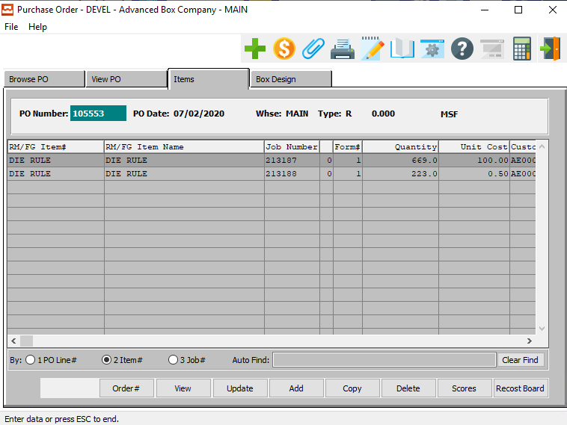

#### ORDER #

Click the ***“Order #”*** button to open the Order Inquiry screen.

#### VIEW

Click the ***“View”*** button to view detailed information about the currently selected Item.

#### UPDATE

To change the currently selected Item, simply click the ***“Update***” button at the bottom of the screen.

#### ADD

Click the ***“Add”*** button at the bottom of the screen to add a new Item.

#### COPY

Click the ***“Copy”*** button to copy information from the currently selected Item.

#### DELETE

To delete the currently selected Item, simply press the ***"D"*** key. Alternatively, click the ***“Delete”*** button at the bottom of the screen.

#### SCORES

Click the ***“Scores”*** button to update the panel sizes for the currently selected item.

#### RECOST BOARD

Click the ***“Recost Board”*** button to group purchase order items for new costs.

### Add/Update Item

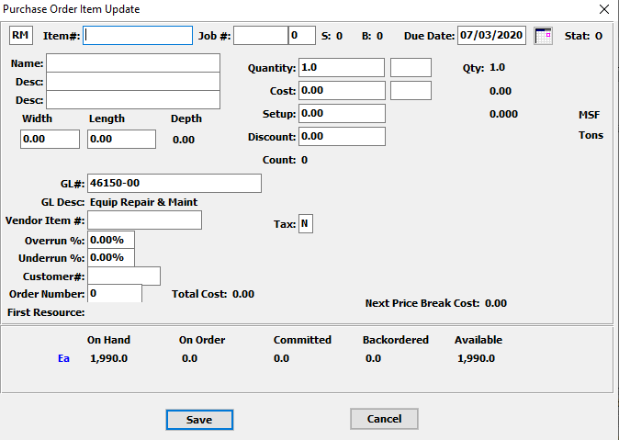

#### SAVE

Click the ***“Save”*** button to save all changes to the current Item.

#### CANCEL

Click the ***“Cancel”*** button to cancel all changes to the Item without saving.

### Add/Update Item Field Definitions

#### Item Type

Valid entries are Finished Goods or Raw Materials.

#### Item #

Enter either the finished goods or raw material item number code to be purchased. Press ***“F1”*** to search for an item. When the ***“F1”*** key is pressed, an option will allow you to choose between a finished goods or raw material item to be purchased. Once you select a file a search capability will exist to find the item you wish to purchase.

#### Job #

The job number field is optional. However, if defined, will provide scheduled receipts reports by job number.

#### Job #: 00

Enter the subsequent job number.

#### Due Date

The required date may be entered for the item. The required date is the date the item is due by.

#### Item Name

This description name transfers from the inventory file.

#### Item Description

This Item Description line repeats twice. The descriptions transfer from the inventory item file.

#### Width

Enter the weight of the item.

#### Length

Enter the length of the item.

#### Quantity

The purchasing quantity is the quantity to order for the purchasing unit of measure. Different materials may be purchased in different unit of measures as defined in the item file for either raw materials or finished goods.

This quantity represents the *Each Sheet* or *Each Leaf*. When the job is missing, it assumes a sheet size of 12”.

Please Note: There is a problem when the Length = 0.

#### Qty UOM

Enter the UOM for the quantity. Alternatively, press the ***“F1”*** key to choose a UOM from a list of valid Units of Measure.

#### Cost

The cost may be entered for the quantity to be purchased.

#### Cost UOM

The purchasing unit of measure will default from the item file.

#### Setup

This is the cost for the setup of this item.

#### Discount

Enter the amount of the discount that is applied to this.

#### GL #

The general ledger account number will default for either raw materials or finished goods entered on the line item screen. For raw materials the account will come from the material cost type file whereas for finished goods the asset account will transfer from the product line file for the product category defined on the items record.

Enter a valid General Ledger account number. To find or change an account press the ***“F1”*** function key to search, press the ***“Page Up” / “Page Down”*** keys to scroll through the account numbers.

#### Vendor Item #

The vendor item number will transfer automatically from the items record if defined.

#### Overrun %

The overrun percentage field allows definition of an allowable overrun percentage compared to the purchase order quantity. Upon receipts for the line item if the quantity received is greater than the allowable underrun, a warning message will appear.

#### Underrun %

The underrun percentage may be entered for allowable quantities over the purchased order quantity. When receiving items, if the item quantity is received is less than the quantity plus the overrun, a warning message will appear.

#### Customer #

Enter the customer number.

#### Order Number

Enter the order number.

#### Tax

This field indicates whether this item is taxable or not. The user may enter a ***“Y”*** for Taxable, or an ***“N”*** for Not Taxable.

### Scores: Update Panel Sizes

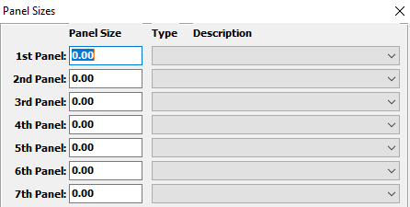

### Box Design

The Box Design screen shows the user the layout of the box for the currently selected Purchase Order.

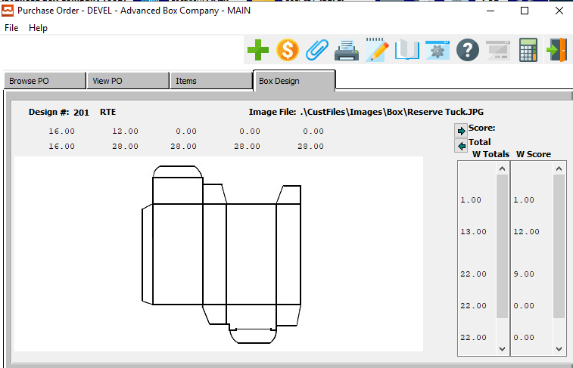

## Purchase Order Notes

To have notes transfer from the vendor file to every new purchase order, there are a few simply steps.

### Group Notes on PO

#### Step One

Add a new user group called PO under N-C for change user group.

#### Step Two

* Add notes to a specific vendor via the BOOK Icon.
* Access the vendor under V-F-1. Then click the Book Icon, then click the View Folder.
* Add the notes for PO group. This will transfer to the fountain pen icon on the view folder of the purchase order when a new purchase order is added.

#### Step Three

* Add a new purchase order and notice the message that notes exist.
* Click the Fountain Pen from the PO View folder to verify the transfer.

#### Step Four

Click the Fountain Pen Icon and notice the notes from the Vendor file transferred.

### SPEC Item Notes on PO

#### Step One

You can also add notes that will be raw material or finished goods item code specific. These notes will be PO line item notes as opposed to PO header notes.

For example, if you want a note on every 200 C line item you would follow these steps.

#### Step Two

Add a new user RM Specification code (at N-Z-6) called PO.

#### Step Three

* Add notes to a specific raw material code via the BOOK Icon.
* Access the raw material code under M-F-1 or M-F-2. Then click the Book Icon, then click the View Folder.
* Add the notes for PO spec code. This will transfer to the fountain pen icon on the “items” detail folder of the purchase order when a new purchase order is added.

#### Step Four

* Add a new purchase order with a line item for the raw material code that you added the note for (in our example 200 C).
* Click the Spec Book Note button verify the transfer.

#### Step Five

* The book note folder shows the notes added for the specific raw material code.
* Depending upon which PO form you select, both the header notes and the line item notes are available to print on the purchase order.

## Print PO Edit List [PU2]

### Selection Parameters

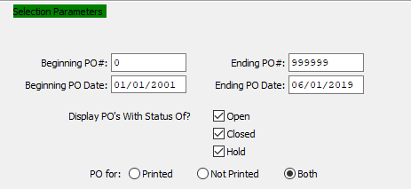

#### Beginning PO # / Ending PO #

Enter the beginning and ending Purchase Order number to appear on this report.

#### Beginning PO Date / Ending PO Date

Enter the beginning and ending Purchase Order Date to run the PO Edit List report for.

#### Display PO’s with Status Of: Open – Toggle Box

To display purchase orders that are open, make sure that this toggle box is checked.

#### Display PO’s with Status Of: Closed – Toggle Box

To display purchase orders that are closed, make sure that this toggle box is checked.

#### Display PO’s with Status Of: Hold – Toggle Box

To display purchase orders that are on hold, make sure that this toggle box is checked.

#### PO For (Choice)

To choose the preferred purchase order type of Printed vs. Not Printed, please make sure the desired option choice bubble is toggled.

### Output Destination

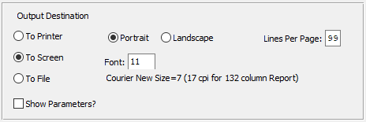

#### Destination Choice

To choose the destination where the document should be printed, please make sure that desired output destination choice bubble is toggled.

#### Layout Choice

To choose the preferred layout of Landscape vs. Portrait, please make sure the desired option choice bubbled is toggled.

#### Lines Per Page

Lines per page on the report when printing.

#### Font

Enter the font number to use with this report (Font 11 is default).

#### Show Parameters? – Toggle Box

To show parameters, make sure that the toggle box is ‘ticked’ with a checkmark.

## Print Purchase Orders [PU3]

### Selection Parameters

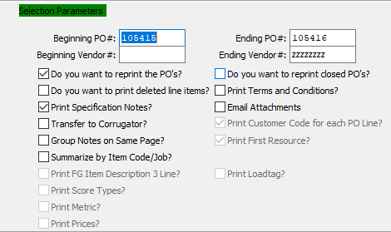

#### Beginning PO # / Ending PO #

Enter the beginning and ending Purchase Order Number to run the report for.

#### Beginning Vendor # / Ending Vendor #

Enter the beginning and ending Vendor Number to run the report for.

#### Do You Want to Reprint the PO’s? – Toggle Box

To reprint purchase orders that have been printed before, make sure that this toggle box is checked.

#### Do You Want to Reprint Closed PO’s? – Toggle Box

To reprint any closed purchase orders within the selection parameters, make sure that this toggle box is checked.

#### Do You Want to Print Deleted Line Items? – Toggle Box

To print any line items that have been deleted from a purchase order, make sure that this toggle box is checked.

#### Print Specification Notes? – Toggle Box

To print any specification notes attached to the purchase orders within the selected parameters, make sure that this toggle box is checked.

#### Transfer to Corrugator? – Toggle Box

To transfer any corrugated items to the corrugator while printing them , make sure that this toggle box is checked.

When printing purchase orders for CorrChoice, the *Transfer to Corrugator* toggle box must be checked, which will create a file with all the required fields for the integration. The CorrChoice file that is create will be the same as the file created for integration to Corrugated Technologies CorrTrim software.

The ***“N”-“k”-“1”*** CorChoise parameter must also be defined whereby the description field houses the location of the file on the box customer’s server, and the character value will dictate the box customer for definitions of the File Transfer Protocol.

#### Group Notes on Same Page? – Toggle Box

To group any purchase order notes within the selected parameters on the same page when printing, make sure that this toggle box is checked.

#### Summarize by Item Code / Job? – Toggle Box

To summarize the purchase orders within the selected parameters by the code or job number, make sure that this toggle box is checked.

#### Print Terms and Conditions? – Toggle Box

To print all terms and conditions of a purchase order, make sure that this toggle box is checked.

#### Email Attachments – Toggle Box

To email any attachments, make sure that this toggle box is checked.

#### Print Customer Code for Each PO Line? – Toggle Box

To print a customer code for each purchase order line within the selected parameters, make sure that this toggle box is checked.

#### Print First Resource? – Toggle Box

To print the first resource for a purchase order, make sure that this toggle box is checked.

#### Print FG Item Description 3 Line? – Toggle Box

To print any finished good item by their third description line, make sure that this toggle box is checked.

#### Print Score Types? – Toggle Box

To print the score types on the report, make sure that this toggle box is checked.

#### Print Metric? – Toggle Box

To print the metric of the item on the report, make sure that this toggle box is checked.

#### Print Prices? – Toggle Box

To print all prices on the report, make sure that this toggle box is checked.

#### Print Load Tag? – Toggle Box

To print the load tags for each item, make sure that this toggle box is checked.

### Output Destination

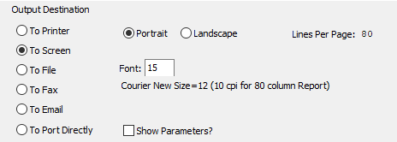

#### Destination Choice

To choose the destination where the document should be printed, please make sure that desired output destination choice bubble is toggled.

#### Layout Choice

To choose the preferred layout of Landscape vs. Portrait, please make sure the desired option choice bubbled is toggled.

#### Lines Per Page

Lines per page on the report when printing.

#### Font

Enter the font number to use with this report (Font 11 is default).

#### Show Parameters? – Toggle Box

To show parameters, make sure that the toggle box is ‘ticked’ with a checkmark.

## Close / Reopen Purchase Orders [PU4]

### Browse PO

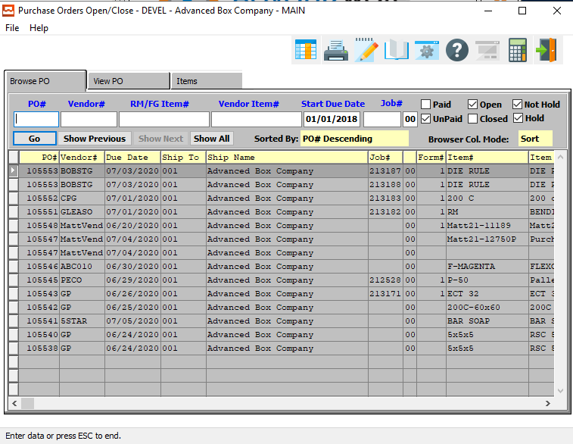

### Browse PO Field Definitions

#### PO #

Enter the PO number for a look-up of a customer or you may use the ***“F1”*** key to find the customer. A partial description may be typed into any field or data may be entered into multiple fields followed by pressing the ***“Go”*** button to sort the fields by the criteria that was entered. Once the data is presented on the screen, the YELLOW column heading may be clicked to sort that specific column in ascending or descending order.

#### Vendor #

Enter the vendor number to look-up your customer or you may use the look-up ***“F1”*** key look-up. A partial description may be typed into any field or data may be entered into multiple fields followed by pressing the ***“Go”*** button to sort the fields by the criteria that was entered. Once the data is presented on the screen, the YELLOW column heading may be clicked to sort that specific column in ascending or descending order.

#### RM/FG Item #

Enter the FG item number or you may use the ***“F1”*** look-up. A partial description may be typed into any field or data may be entered into multiple fields followed by pressing the ***“Go”*** button to sort the fields by the criteria that was entered. Once the data is presented on the screen, the YELLOW column heading may be clicked to sort that specific column in ascending or descending order.

#### Vendor Item #

Enter the vendor item number or press ***“F1”*** to search for a vendor. A partial description may be typed into any field or data may be entered into multiple fields followed by pressing the ***“Go”*** button to sort the fields by the criteria that was entered. Once the data is presented on the screen, the YELLOW column heading may be clicked to sort that specific column in ascending or descending order.

#### Start Due Date

Enter the start due date. A partial description may be typed into any field or data may be entered into multiple fields followed by pressing the ***“Go”*** button to sort the fields by the criteria that was entered. Once the data is presented on the screen, the YELLOW column heading may be clicked to sort that specific column in ascending or descending order.

#### Job #

Enter the job number or you can do a ***“F1”*** look-up from list. A partial description may be typed into any field or data may be entered into multiple fields followed by pressing the ***“Go”*** button to sort the fields by the criteria that was entered. Once the data is presented on the screen, the YELLOW column heading may be clicked to sort that specific column in ascending or descending order.

#### Job #: 00

Enter the subsequent job number to search for.

#### Paid – Toggle Box

To search for Purchase Orders that have been paid, make sure that the Paid toggle box is checked.

#### Unpaid – Toggle Box

To search for Purchase Orders that have not been paid, make sure that the Unpaid toggle box is checked.

#### Open – Toggle Box

To search for Purchase Orders that are still open, make sure that the Open toggle box is checked.

#### Closed – Toggle Box

To search for Purchase Orders that are closed, make sure that the Closed toggle box is checked.

#### Not Hold – Toggle Box

To search for Purchase Orders whose status is not on hold, make sure that the Not Hold toggle box is checked.

#### Hold – Toggle Box

To search for Purchase Orders whose status is on hold, make sure that the Hold toggle box is checked.

### View PO

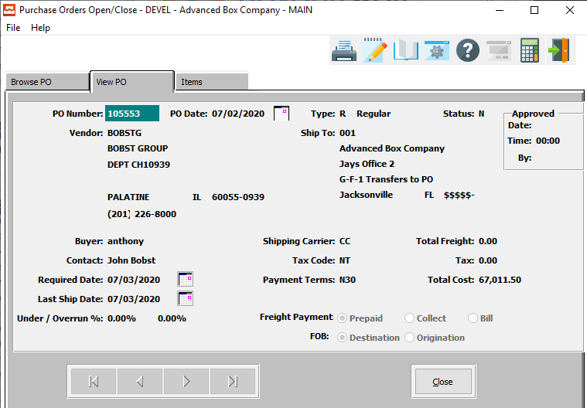

#### CLOSE

Click the ***“Close”*** button to close a PO whose status is currently “Open”.

#### OPEN

Click the ***“Open”*** button to open a PO whose status is currently “Closed”.

### Items

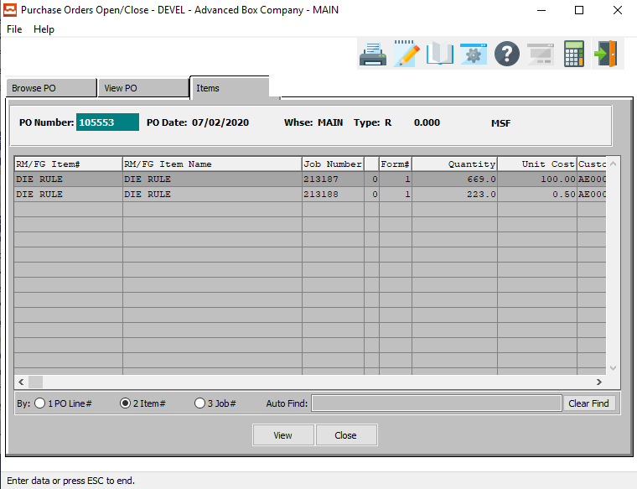

#### VIEW

Click the ***“View”*** button to view detailed information about the currently selected Item.

#### CLOSE

Click the ***“Close”*** button to close a PO whose status is currently “Open”.

#### OPEN

Click the ***“Open”*** button to open a PO whose status is currently “Closed”.

### View Detailed Item

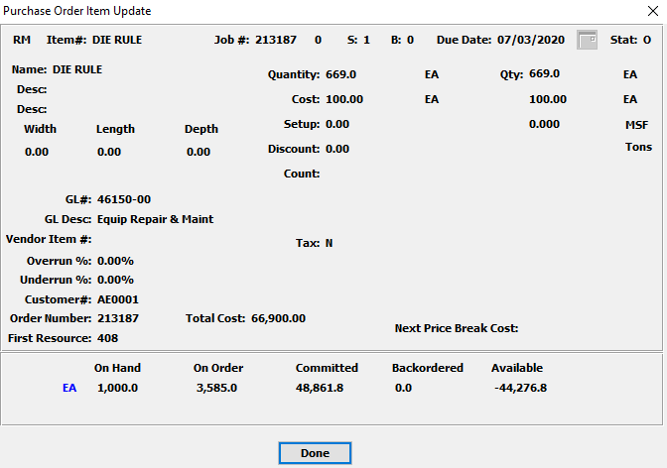

#### DONE

Click the ***“Done”*** button to exit the Detailed Item screen.

# **Query Purchase Orders [PQ]**

## PO Inquiry [PQ1]

### Browse PO

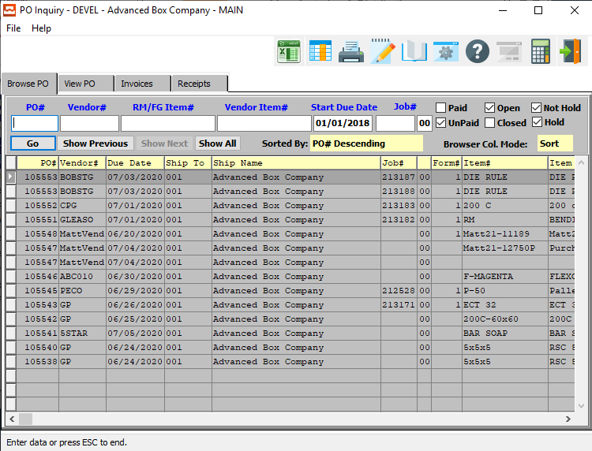

### Browse PO Field Definitions

#### PO #

Enter the PO number for a look-up of a customer or you may use the ***“F1”*** key to find the customer. A partial description may be typed into any field or data may be entered into multiple fields followed by pressing the ***“Go”*** button to sort the fields by the criteria that was entered. Once the data is presented on the screen, the YELLOW column heading may be clicked to sort that specific column in ascending or descending order.

#### Vendor #

Enter the vendor number to look-up your customer or you may use the look-up ***“F1”*** key look-up. A partial description may be typed into any field or data may be entered into multiple fields followed by pressing the ***“Go”*** button to sort the fields by the criteria that was entered. Once the data is presented on the screen, the YELLOW column heading may be clicked to sort that specific column in ascending or descending order.

#### RM/FG Item #

Enter the FG item number or you may use the ***“F1”*** look-up. A partial description may be typed into any field or data may be entered into multiple fields followed by pressing the ***“Go”*** button to sort the fields by the criteria that was entered. Once the data is presented on the screen, the YELLOW column heading may be clicked to sort that specific column in ascending or descending order.

#### Vendor Item #

Enter the vendor item number or press ***“F1”*** to search for a vendor. A partial description may be typed into any field or data may be entered into multiple fields followed by pressing the ***“Go”*** button to sort the fields by the criteria that was entered. Once the data is presented on the screen, the YELLOW column heading may be clicked to sort that specific column in ascending or descending order.

#### Start Due Date

Enter the start due date. A partial description may be typed into any field or data may be entered into multiple fields followed by pressing the ***“Go”*** button to sort the fields by the criteria that was entered. Once the data is presented on the screen, the YELLOW column heading may be clicked to sort that specific column in ascending or descending order.

#### Job #

Enter the job number or you can do a ***“F1”*** look-up from list. A partial description may be typed into any field or data may be entered into multiple fields followed by pressing the ***“Go”*** button to sort the fields by the criteria that was entered. Once the data is presented on the screen, the YELLOW column heading may be clicked to sort that specific column in ascending or descending order.

#### Job #: 00

Enter the subsequent job number to search for.

#### Paid – Toggle Box

To search for Purchase Orders that have been paid, make sure that the Paid toggle box is checked.

#### Unpaid – Toggle Box

To search for Purchase Orders that have not been paid, make sure that the Unpaid toggle box is checked.

#### Open – Toggle Box

To search for Purchase Orders that are still open, make sure that the Open toggle box is checked.

#### Closed – Toggle Box

To search for Purchase Orders that are closed, make sure that the Closed toggle box is checked.

#### Not Hold – Toggle Box

To search for Purchase Orders whose status is not on hold, make sure that the Not Hold toggle box is checked.

#### Hold – Toggle Box

To search for Purchase Orders whose status is on hold, make sure that the Hold toggle box is checked.

### View PO

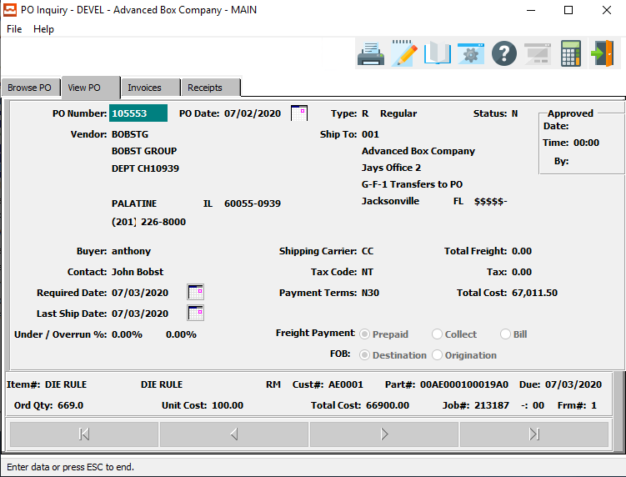

### Invoices

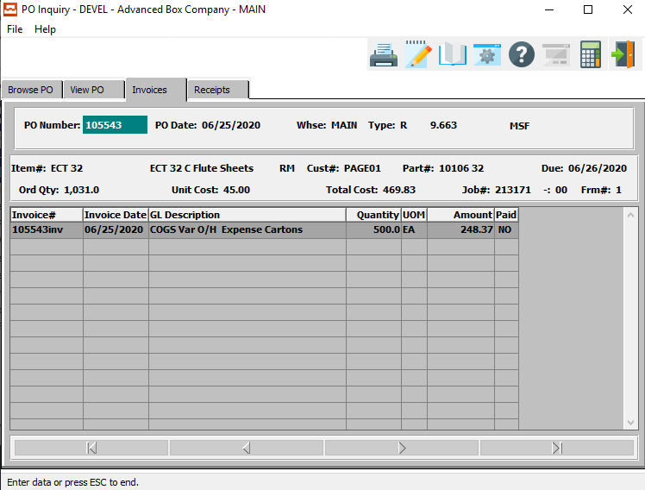

### Receipts

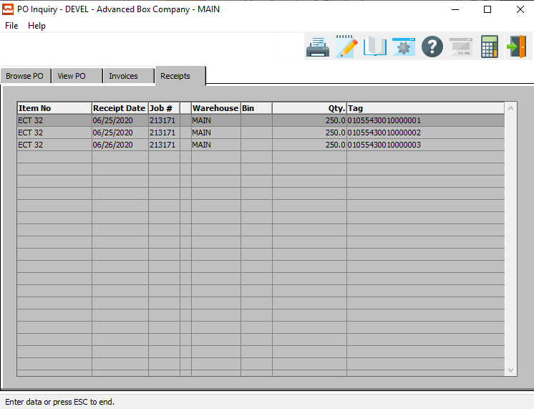

# **Reports for Purchasing [PR]**

## Sheets on Order [PR1]

### Selection Parameters

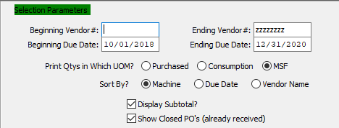

#### Beginning Vendor # / Ending Vendor #

Enter the beginning and ending Vendor Number to run the Sheets on Order report for.

#### Beginning Due Date / Ending Due Date

Enter the beginning and ending Due Date to run the Sheets on Order report for.

#### Print Quantities in Which UOM? (Choice)

To choose the preferred Unit of Measure of Purchased vs. Consumption vs. MSF, please make sure the desired option choice bubble is toggled.

#### Sort By? (Choice)

To choose the preferred sorting method of Machine vs. Due Date vs. Vendor Name, please make sure the desired option choice bubble is toggled.

#### Display Subtotal? -Toggle Box

To display the subtotal for each order within the selected parameters, make sure that the Display Subtotal toggle box is checked.

#### Show Closed PO’s (Already Received) – Toggle Box

To show any purchase order that are marked as closed, or have already been received, make sure that this toggle box is checked.

### Available and Selected Columns

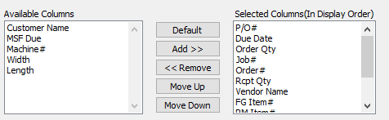

#### Available Columns

The user may choose which columns they wish to have on the report printout. As the user selects their choices, they will appear on the ‘*Selected Columns’* list.

#### Selected Columns (In Display Order)

The columns that the user has chosen from the ‘*Available Columns’* list. The order that these columns are displayed in here is the order in which they will print on the report.

#### Default

Click the ***“Default****”* button to sort the ‘*Selected Columns’* list by the default system parameters.

#### Add >>

Click on the selected item from the ‘*Available Columns’* list to highlight it, then click the ***“Add”*** button to add the selected column to the ‘*Selected Columns’* list.

#### << Remove

Click on the selected item from the ‘*Selected Columns’* list to highlight it, then click the ***“Remove”*** button to remove the selected column to the ‘*Selected Columns’* list.

#### Move Up

Within the ‘*Selected Columns’* list, the user may choose the order they wish the selected columns to print in. In order to change the order of the columns, the user can click on a selection to highlight it. By then clicking the ***“Move Up***” button, the user can change its position on the report.

#### Move Down

Within the ‘*Selected Columns’* list, the user may choose the order they wish the selected columns to print in. In order to change the order of the columns, the user can click on a selection to highlight it. By then clicking the ***“Move Down***” button, the user can change its position on the report.

### Output Destination

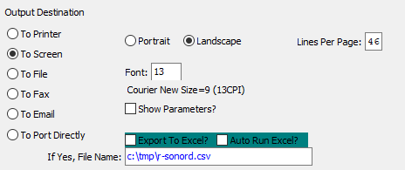

#### Destination Choice

To choose the destination where the document should be printed, please make sure that desired output destination choice bubble is toggled.

#### Layout Choice

To choose the preferred layout of Landscape vs. Portrait, please make sure the desired option choice bubbled is toggled.

#### Lines Per Page

Lines per page on the report when printing.

#### Font

Enter the font number to use with this report (Font 11 is default).

#### Show Parameters? – Toggle Box

To show parameters, make sure that the toggle box is ‘ticked’ with a checkmark.

#### Export to Excel? – Toggle Box

To export the printed file to an excel document, make sure that the Export to Excel toggle box is checked.

#### Auto Run Excel? – Toggle Box

To automatically open the new excel document, make sure that the Auto Run Excel toggle box is checked.

#### If Yes, File Name

If exporting the file to Excel, enter the desired file name.

## Scheduled Reports [PR2]

### Selection Parameters

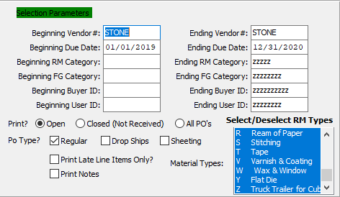

#### Beginning Vendor # / Ending Vendor #

Enter the beginning and ending Vendor Number to run the Scheduled report for.

#### Beginning Due Date / Ending Due Date

Enter the beginning and ending Due Date to run the Scheduled report for.

#### Beginning RM Category / Ending RM Category

Enter the beginning and ending Raw Material Category to run the Scheduled report for.

#### Beginning FG Category / Ending FG Category

Enter the beginning and ending Finished Good Category to run the Scheduled report for.

#### Beginning Buyer ID / Ending Buyer ID

Enter the beginning and ending Buyer ID to run the Scheduled report for.

#### Beginning User ID / Ending User ID

Enter the beginning and ending User ID to run the Scheduled report for.

#### Print? (Choice)

To choose the preferred print option of Open vs. Closed (OR All), please make sure the desired option choice bubble is toggled.

#### PO Type: Regular – Toggle Box

To include regular purchase orders on the report, make sure that the Regular toggle box is checked.

#### PO Type: Drop Ships – Toggle Box

To include drop shipped purchase orders on the report, make sure that the Drop Ships toggle box is checked.

#### PO Type: Sheeting – Toggle Box

To include sheeting purchase orders on the report, make sure that the Sheeting toggle box is checked.

#### Print Late Line Items Only? – Toggle Box

To only print line items that are past their due date, make sure that this toggle box is checked.

#### Print Notes – Toggle Box

To print any notes connect to the purchase orders within the selected parameters, make sure that the Print Notes toggle box is checked.

### Select / Deselect RM Types

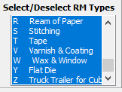

The user may choose multiple Material Types from this list by using the ***“Control – Click”*** method. A selected Material Type will by highlighted within the list, and only highlighted Material Types will be used by the system.

### Export Selection

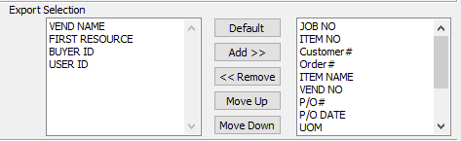

#### Available Columns

The user may choose which columns they wish to have on the report printout. As the user selects their choices, they will appear on the ‘*Selected Columns’* list.

#### Selected Columns (In Display Order)

The columns that the user has chosen from the ‘*Available Columns’* list. The order that these columns are displayed in here is the order in which they will print on the report.

#### Default

Click the ***“Default****”* button to sort the ‘*Selected Columns’* list by the default system parameters.

#### Add >>

Click on the selected item from the ‘*Available Columns’* list to highlight it, then click the ***“Add”*** button to add the selected column to the ‘*Selected Columns’* list.

#### << Remove

Click on the selected item from the ‘*Selected Columns’* list to highlight it, then click the ***“Remove”*** button to remove the selected column to the ‘*Selected Columns’* list.

#### Move Up

Within the ‘*Selected Columns’* list, the user may choose the order they wish the selected columns to print in. In order to change the order of the columns, the user can click on a selection to highlight it. By then clicking the ***“Move Up***” button, the user can change its position on the report.

#### Move Down

Within the ‘*Selected Columns’* list, the user may choose the order they wish the selected columns to print in. In order to change the order of the columns, the user can click on a selection to highlight it. By then clicking the ***“Move Down***” button, the user can change its position on the report.

### Output Destination

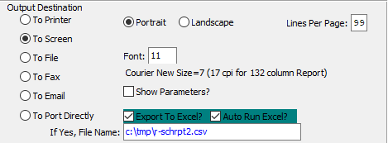

#### Destination Choice

To choose the destination where the document should be printed, please make sure that desired output destination choice bubble is toggled.

#### Layout Choice

To choose the preferred layout of Landscape vs. Portrait, please make sure the desired option choice bubbled is toggled.

#### Lines Per Page

Lines per page on the report when printing.

#### Font

Enter the font number to use with this report (Font 11 is default).

#### Show Parameters? – Toggle Box

To show parameters, make sure that the toggle box is ‘ticked’ with a checkmark.

#### Export to Excel? – Toggle Box

To export the printed file to an excel document, make sure that the Export to Excel toggle box is checked.

#### Auto Run Excel? – Toggle Box

To automatically open the new excel document, make sure that the Auto Run Excel toggle box is checked.

#### If Yes, File Name

If exporting the file to Excel, enter the desired file name.

## PO FG/RM History [PR3]

### Selection Parameters

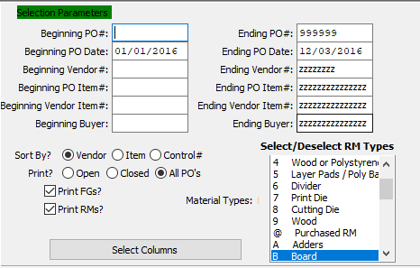

#### Beginning PO # / Ending PO #

Enter the beginning and ending Purchase Order Number to run the History report for.

#### Beginning PO Date / Ending PO Date

Enter the beginning and ending Purchase Order Date to run the History report for.

#### Beginning Vendor # / Ending Vendor #

Enter the beginning and ending Vendor Number to run the History report for.

#### Beginning PO Item # / Ending PO Item #

Enter the beginning and ending Purchase Order Item Number to run the History report for.

#### Beginning Vendor Item # / Ending Vendor Item #

Enter the beginning and ending Vendor Item Number to run the History report for.

#### Beginning Buyer / Ending Buyer

Enter the beginning and ending Buyer to run the History report for.

#### Sort By? (Choice)

To choose the preferred sorting method of Vendor vs. Item vs. Control Number, please make sure the desired option choice bubble is toggled.

#### Print? (Choice)

To choose the preferred printing option of Open vs. Closed (Or All), please make sure the desired option choice bubble is toggled.

#### Print FG’s? – Toggle Box

To print any finished good items on the report, make sure that the Print FG’s toggle box is checked.

#### Print RM’s? – Toggle Box

To print any raw material items on the report, make sure that the Print RM’s toggle box is checked.

#### SELECT COLUMNS

Click the ***“Select Columns”*** button to bring up the popup window in which the user may select which columns they wish to print to the report, and in what order they will be arranged.

### Select / Deselect RM Types

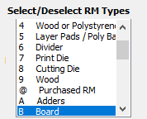

The user may choose multiple Material Types from this list by using the ***“Control – Click”*** method. A selected Material Type will by highlighted within the list, and only highlighted Material Types will be used by the system.

### Available and Selected Columns

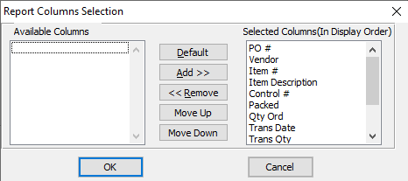

#### Available Columns

The user may choose which columns they wish to have on the report printout. As the user selects their choices, they will appear on the ‘*Selected Columns’* list.

#### Selected Columns (In Display Order)

The columns that the user has chosen from the ‘*Available Columns’* list. The order that these columns are displayed in here is the order in which they will print on the report.

#### Default

Click the ***“Default****”* button to sort the ‘*Selected Columns’* list by the default system parameters.

#### Add >>

Click on the selected item from the ‘*Available Columns’* list to highlight it, then click the ***“Add”*** button to add the selected column to the ‘*Selected Columns’* list.

#### << Remove

Click on the selected item from the ‘*Selected Columns’* list to highlight it, then click the ***“Remove”*** button to remove the selected column to the ‘*Selected Columns’* list.

#### Move Up

Within the ‘*Selected Columns’* list, the user may choose the order they wish the selected columns to print in. In order to change the order of the columns, the user can click on a selection to highlight it. By then clicking the ***“Move Up***” button, the user can change its position on the report.

#### Move Down

Within the ‘*Selected Columns’* list, the user may choose the order they wish the selected columns to print in. In order to change the order of the columns, the user can click on a selection to highlight it. By then clicking the ***“Move Down***” button, the user can change its position on the report.

### Output Destination

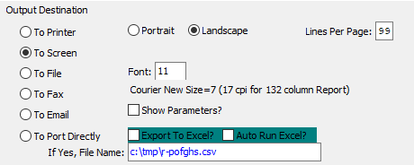

#### Destination Choice

To choose the destination where the document should be printed, please make sure that desired output destination choice bubble is toggled.

#### Layout Choice

To choose the preferred layout of Landscape vs. Portrait, please make sure the desired option choice bubbled is toggled.

#### Lines Per Page

Lines per page on the report when printing.

#### Font

Enter the font number to use with this report (Font 11 is default).

#### Show Parameters? – Toggle Box

To show parameters, make sure that the toggle box is ‘ticked’ with a checkmark.

#### Export to Excel? – Toggle Box

To export the printed file to an excel document, make sure that the Export to Excel toggle box is checked.

#### Auto Run Excel? – Toggle Box

To automatically open the new excel document, make sure that the Auto Run Excel toggle box is checked.

## Material Required for Job [PR4]

### Selection Parameters

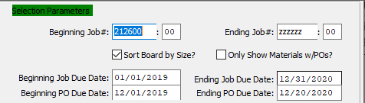

#### Beginning Job # / Ending Job #

Enter the beginning and ending Job Number to run the Material Required report for.

#### Beginning Job #: 00 / Ending Job #: 00

Enter the beginning and ending Subsequent Job Number to run the Material Required report for.

#### Sort Board by Size? – Toggle Box

To sort all materials by their board size, make sure that the Sort Board by Size toggle box is checked.

#### Only Show Materials with PO’s? – Toggle Box

To only show materials that have purchase orders attached, make sure that this toggle box is checked.

#### Beginning Job Due Date / Ending Job Due Date

Enter the beginning and ending Job Due Date to run the Material Required report for.

#### Beginning PO Due Date / Ending PO Due Date

Enter the beginning and ending Purchase Order Due Date to run the Material Required report for.

### Select / Deselect Material Types

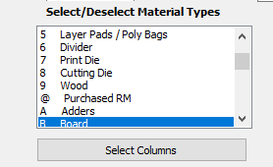

The user may choose multiple Material Types from this list by using the ***“Control – Click”*** method. A selected Material Type will by highlighted within the list, and only highlighted Material Types will be used by the system.

#### SELECT COLUMNS

Click the ***“Select Columns”*** button to bring up the popup window in which the user may select which columns they wish to print to the report, and in what order they will be arranged.

### Available and Selected Columns

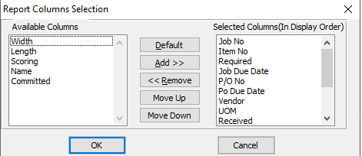

#### Available Columns

The user may choose which columns they wish to have on the report printout. As the user selects their choices, they will appear on the ‘*Selected Columns’* list.

#### Selected Columns (In Display Order)

The columns that the user has chosen from the ‘*Available Columns’* list. The order that these columns are displayed in here is the order in which they will print on the report.

#### Default

Click the ***“Default****”* button to sort the ‘*Selected Columns’* list by the default system parameters.

#### Add >>

Click on the selected item from the ‘*Available Columns’* list to highlight it, then click the ***“Add”*** button to add the selected column to the ‘*Selected Columns’* list.

#### << Remove

Click on the selected item from the ‘*Selected Columns’* list to highlight it, then click the ***“Remove”*** button to remove the selected column to the ‘*Selected Columns’* list.

#### Move Up

Within the ‘*Selected Columns’* list, the user may choose the order they wish the selected columns to print in. In order to change the order of the columns, the user can click on a selection to highlight it. By then clicking the ***“Move Up***” button, the user can change its position on the report.

#### Move Down

Within the ‘*Selected Columns’* list, the user may choose the order they wish the selected columns to print in. In order to change the order of the columns, the user can click on a selection to highlight it. By then clicking the ***“Move Down***” button, the user can change its position on the report.

### Output Destination

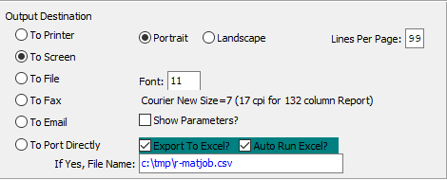

#### Destination Choice

To choose the destination where the document should be printed, please make sure that desired output destination choice bubble is toggled.

#### Layout Choice

To choose the preferred layout of Landscape vs. Portrait, please make sure the desired option choice bubbled is toggled.

#### Lines Per Page

Lines per page on the report when printing.

#### Font

Enter the font number to use with this report (Font 11 is default).

#### Show Parameters? – Toggle Box

To show parameters, make sure that the toggle box is ‘ticked’ with a checkmark.

#### Export to Excel? – Toggle Box

To export the printed file to an excel document, make sure that the Export to Excel toggle box is checked.

#### Auto Run Excel? – Toggle Box

To automatically open the new excel document, make sure that the Auto Run Excel toggle box is checked.

#### If Yes, File Name

If exporting the file to Excel, enter the desired file name.

## PO Purchased Variance [PR5]

### Selection Parameters

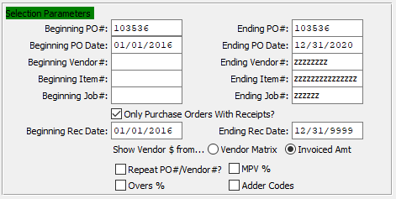

#### Beginning PO # / Ending PO #

Enter the beginning and ending Purchase Order Number to run the Purchased Variant report for.

#### Beginning PO Date / Ending PO Date

Enter the beginning and ending Purchase Order Date to run the Purchased Variant report for.

#### Beginning Vendor # / Ending Vendor #

Enter the beginning and ending Vendor Number to run the Purchased Variant report for.

#### Beginning Item # / Ending Item #

Enter the beginning and ending Item Number to run the Purchased Variant report for.

#### Beginning Job # / Ending Job #

Enter the beginning and ending Job Number to run the Purchased Variant report for.

#### Only Purchase Orders with Receipts? – Toggle Box

To only include purchase orders with receipts on the report, make sure that this toggle box is checked.

#### Beginning Rec. Date / Ending Rec. Date

Enter the beginning and ending Receipt Date to run the Purchased Variant report for.

#### Show Vendor $ From (Choice)

To choose the preferred sorting method of Vendor Matrix vs. Invoice Amounr, please make sure the desired option choice bubble is toggled.

#### Repeat PO # / Vendor #? – Toggle Box

To include repeated purchase orders and/or vendor numbers within the selected parameters on the report, make sure that this toggle box is checked.

#### Overs % – Toggle Box

To include overrun percentages, make sure that the Overs % toggle box is checked.

#### MPV % – Toggle Box

To include the MPV % on the report, make sure that the MPV % toggle box is checked.

#### Adder Codes – Toggle Box

To include all adder codes on the report, make sure that the Adder Codes toggle box is checked.

### Available and Selected Columns

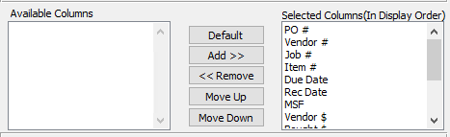

#### Available Columns

The user may choose which columns they wish to have on the report printout. As the user selects their choices, they will appear on the ‘*Selected Columns’* list.

#### Selected Columns (In Display Order)

The columns that the user has chosen from the ‘*Available Columns’* list. The order that these columns are displayed in here is the order in which they will print on the report.

#### Default

Click the ***“Default****”* button to sort the ‘*Selected Columns’* list by the default system parameters.

#### Add >>

Click on the selected item from the ‘*Available Columns’* list to highlight it, then click the ***“Add”*** button to add the selected column to the ‘*Selected Columns’* list.

#### << Remove

Click on the selected item from the ‘*Selected Columns’* list to highlight it, then click the ***“Remove”*** button to remove the selected column to the ‘*Selected Columns’* list.

#### Move Up

Within the ‘*Selected Columns’* list, the user may choose the order they wish the selected columns to print in. In order to change the order of the columns, the user can click on a selection to highlight it. By then clicking the ***“Move Up***” button, the user can change its position on the report.

#### Move Down

Within the ‘*Selected Columns’* list, the user may choose the order they wish the selected columns to print in. In order to change the order of the columns, the user can click on a selection to highlight it. By then clicking the ***“Move Down***” button, the user can change its position on the report.

### Output Destination

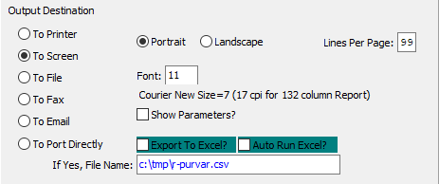

#### Destination Choice

To choose the destination where the document should be printed, please make sure that desired output destination choice bubble is toggled.

#### Layout Choice

To choose the preferred layout of Landscape vs. Portrait, please make sure the desired option choice bubbled is toggled.

#### Lines Per Page

Lines per page on the report when printing.

#### Font

Enter the font number to use with this report (Font 11 is default).

#### Show Parameters? – Toggle Box

To show parameters, make sure that the toggle box is ‘ticked’ with a checkmark.

#### Export to Excel? – Toggle Box

To export the printed file to an excel document, make sure that the Export to Excel toggle box is checked.

#### Auto Run Excel? – Toggle Box

To automatically open the new excel document, make sure that the Auto Run Excel toggle box is checked.

#### If Yes, File Name

If exporting the file to Excel, enter the desired file name.

## PO Vendor Analysis [PR6]

### Selection Parameters

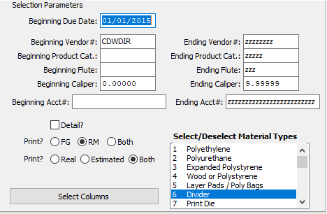

#### Beginning Due Date

Enter the beginning Due Date to run the Vendor Analysis report for.

#### Beginning Vendor # / Ending Vendor #

Enter the beginning and ending Vendor Number to run the Vendor Analysis report for.

#### Beginning Product Category / Ending Product Category

Enter the beginning and ending Product Category to run the Vendor Analysis report for.

#### Beginning Flute / Ending Flute

Enter the beginning and ending Flute to run the Vendor Analysis report for.

#### Beginning Caliper / Ending Caliper

Enter the beginning and ending Caliper to run the Vendor Analysis report for.

#### Beginning Account # / Ending Account #

Enter the beginning and ending Account Number to run the Vendor Analysis report for.

#### Detail? – Toggle Box

To include the detailed information for each item on the report, make sure that the Detail toggle box is checked.

#### Print: FG/RM Type (Choice)

To choose the preferred printing option of Finished Good vs. Raw Material (Or Both), please make sure the desired option choice bubble is toggled.

#### Print: R/E Type (Choice)

To choose the preferred printing option of Real vs. Estimated (Or Both), please make sure the desired option choice bubble is toggled.

#### SELECT COLUMNS

Click the ***“Select Columns”*** button to bring up the popup window in which the user may select which columns they wish to print to the report, and in what order they will be arranged.

### Select / Deselect Material Types

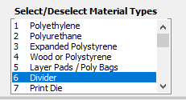

The user may choose multiple Material Types from this list by using the ***“Control – Click”*** method. A selected Material Type will by highlighted within the list, and only highlighted Material Types will be used by the system.

### Available and Selected Columns

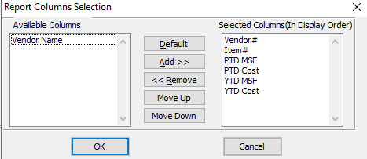

#### Available Columns

The user may choose which columns they wish to have on the report printout. As the user selects their choices, they will appear on the ‘*Selected Columns’* list.

#### Selected Columns (In Display Order)

The columns that the user has chosen from the ‘*Available Columns’* list. The order that these columns are displayed in here is the order in which they will print on the report.

#### Default

Click the ***“Default****”* button to sort the ‘*Selected Columns’* list by the default system parameters.

#### Add >>

Click on the selected item from the ‘*Available Columns’* list to highlight it, then click the ***“Add”*** button to add the selected column to the ‘*Selected Columns’* list.

#### << Remove

Click on the selected item from the ‘*Selected Columns’* list to highlight it, then click the ***“Remove”*** button to remove the selected column to the ‘*Selected Columns’* list.

#### Move Up

Within the ‘*Selected Columns’* list, the user may choose the order they wish the selected columns to print in. In order to change the order of the columns, the user can click on a selection to highlight it. By then clicking the ***“Move Up***” button, the user can change its position on the report.

#### Move Down

Within the ‘*Selected Columns’* list, the user may choose the order they wish the selected columns to print in. In order to change the order of the columns, the user can click on a selection to highlight it. By then clicking the ***“Move Down***” button, the user can change its position on the report.

### Output Destination

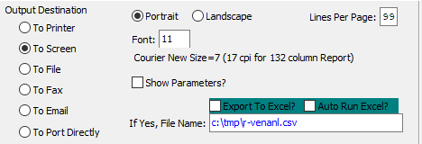

#### Destination Choice

To choose the destination where the document should be printed, please make sure that desired output destination choice bubble is toggled.

#### Layout Choice

To choose the preferred layout of Landscape vs. Portrait, please make sure the desired option choice bubbled is toggled.

#### Lines Per Page

Lines per page on the report when printing.

#### Font

Enter the font number to use with this report (Font 11 is default).

#### Show Parameters? – Toggle Box

To show parameters, make sure that the toggle box is ‘ticked’ with a checkmark.

#### Export to Excel? – Toggle Box

To export the printed file to an excel document, make sure that the Export to Excel toggle box is checked.

#### Auto Run Excel? – Toggle Box

To automatically open the new excel document, make sure that the Auto Run Excel toggle box is checked.

#### If Yes, File Name

If exporting the file to Excel, enter the desired file name.

## PO Receipts Not Vouchered [PR7]

### Selection Parameters

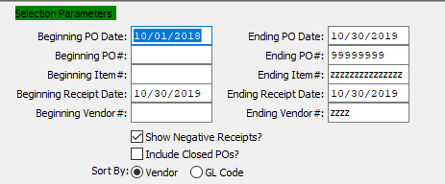

#### Beginning PO Date / Ending PO Date

Enter the beginning and ending Purchase Order Date to run the Receipts Not Vouchered report for.

#### Beginning PO # / Ending PO #

Enter the beginning and ending Purchase Order Number to run the Receipts Not Vouchered report for.

#### Beginning Item # / Ending Item #

Enter the beginning and ending Item Number to run the Receipts Not Vouchered report for.

#### Beginning Receipt Date / Ending Receipt Date

Enter the beginning and ending Receipt Date to run the Receipts Not Vouchered report for.

#### Beginning Vendor # / Ending Vendor #

Enter the beginning and ending Vendor Number to run the Receipts Not Vouchered report for.

#### Show Negative Receipts? – Toggle Box

To include any negative receipts on the report, make sure that the Show Negative Receipts toggle box is checked.

#### Include Closed PO’s? – Toggle Box

To include any closed purchase orders on the report, make sure that this toggle box is checked.

#### Sort By (Choice)

To choose the preferred sorting method of Vendor vs. General Ledger Code, please make sure the desired option choice bubble is toggled.

### Available and Selected Columns

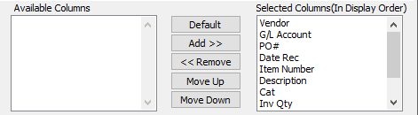

#### Available Columns

The user may choose which columns they wish to have on the report printout. As the user selects their choices, they will appear on the ‘*Selected Columns’* list.

#### Selected Columns (In Display Order)

The columns that the user has chosen from the ‘*Available Columns’* list. The order that these columns are displayed in here is the order in which they will print on the report.

#### Default

Click the ***“Default****”* button to sort the ‘*Selected Columns’* list by the default system parameters.

#### Add >>

Click on the selected item from the ‘*Available Columns’* list to highlight it, then click the ***“Add”*** button to add the selected column to the ‘*Selected Columns’* list.

#### << Remove

Click on the selected item from the ‘*Selected Columns’* list to highlight it, then click the ***“Remove”*** button to remove the selected column to the ‘*Selected Columns’* list.

#### Move Up

Within the ‘*Selected Columns’* list, the user may choose the order they wish the selected columns to print in. In order to change the order of the columns, the user can click on a selection to highlight it. By then clicking the ***“Move Up***” button, the user can change its position on the report.

#### Move Down

Within the ‘*Selected Columns’* list, the user may choose the order they wish the selected columns to print in. In order to change the order of the columns, the user can click on a selection to highlight it. By then clicking the ***“Move Down***” button, the user can change its position on the report.

### Output Destination

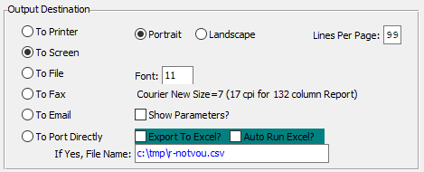

#### Destination Choice

To choose the destination where the document should be printed, please make sure that desired output destination choice bubble is toggled.

#### Layout Choice

To choose the preferred layout of Landscape vs. Portrait, please make sure the desired option choice bubbled is toggled.

#### Lines Per Page

Lines per page on the report when printing.

#### Font

Enter the font number to use with this report (Font 11 is default).

#### Show Parameters? – Toggle Box

To show parameters, make sure that the toggle box is ‘ticked’ with a checkmark.

#### Export to Excel? – Toggle Box

To export the printed file to an excel document, make sure that the Export to Excel toggle box is checked.

#### Auto Run Excel? – Toggle Box

To automatically open the new excel document, make sure that the Auto Run Excel toggle box is checked.

#### If Yes, File Name

If exporting the file to Excel, enter the desired file name.

## Shipment Approval Report [PR8]

### Selection Parameters

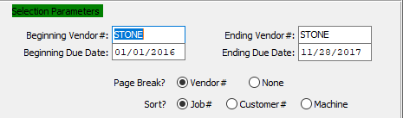

#### Beginning Vendor # / Ending Vendor #

Enter the beginning and ending Vendor Number to run the Shipment Approval report for.

#### Beginning Due Date / Ending Due Date

Enter the beginning and ending Due Date to run the Shipment Approval report for.

#### Page Break? (Choice)

To choose the preferred page break option of Vendor Number vs. Nothing, please make sure the desired option choice bubble is toggled.

#### Sort? (Choice)

To choose the preferred sorting method of Job Number vs. Customer number vs. Machine, please make sure the desired option choice bubble is toggled.

### Available and Selected Columns

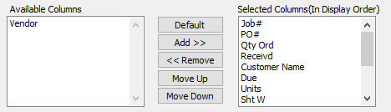

#### Available Columns

The user may choose which columns they wish to have on the report printout. As the user selects their choices, they will appear on the ‘*Selected Columns’* list.

#### Selected Columns (In Display Order)

The columns that the user has chosen from the ‘*Available Columns’* list. The order that these columns are displayed in here is the order in which they will print on the report.

#### Default

Click the ***“Default****”* button to sort the ‘*Selected Columns’* list by the default system parameters.

#### Add >>

Click on the selected item from the ‘*Available Columns’* list to highlight it, then click the ***“Add”*** button to add the selected column to the ‘*Selected Columns’* list.

#### << Remove

Click on the selected item from the ‘*Selected Columns’* list to highlight it, then click the ***“Remove”*** button to remove the selected column to the ‘*Selected Columns’* list.

#### Move Up

Within the ‘*Selected Columns’* list, the user may choose the order they wish the selected columns to print in. In order to change the order of the columns, the user can click on a selection to highlight it. By then clicking the ***“Move Up***” button, the user can change its position on the report.

#### Move Down

Within the ‘*Selected Columns’* list, the user may choose the order they wish the selected columns to print in. In order to change the order of the columns, the user can click on a selection to highlight it. By then clicking the ***“Move Down***” button, the user can change its position on the report.

### Output Destination

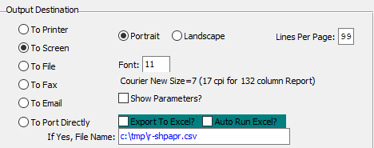

#### Destination Choice

To choose the destination where the document should be printed, please make sure that desired output destination choice bubble is toggled.

#### Layout Choice

To choose the preferred layout of Landscape vs. Portrait, please make sure the desired option choice bubbled is toggled.

#### Lines Per Page

Lines per page on the report when printing.

#### Font

Enter the font number to use with this report (Font 11 is default).

#### Show Parameters? – Toggle Box

To show parameters, make sure that the toggle box is ‘ticked’ with a checkmark.

#### Export to Excel? – Toggle Box

To export the printed file to an excel document, make sure that the Export to Excel toggle box is checked.

#### Auto Run Excel? – Toggle Box

To automatically open the new excel document, make sure that the Auto Run Excel toggle box is checked.

## PO FG/RM History by Custom [PR9]

### Selection Parameters

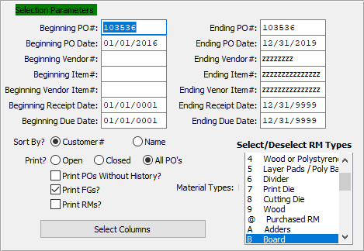

#### Beginning PO # / Ending PO #

Enter the beginning and ending Purchase Order Number to run the History report for.

#### Beginning PO Date / Ending PO Date

Enter the beginning and ending Purchase Order Date to run the History report for.

#### Beginning Vendor # / Ending Vendor #

Enter the beginning and ending Vendor Number to run the History report for.

#### Beginning Item # / Ending Item #

Enter the beginning and ending Item Number to run the History report for.

#### Beginning Vendor Item # / Ending Vendor Item #

Enter the beginning and ending Vendor Item Number to run the History report for.

#### Beginning Receipt Date / Ending Receipt Date

Enter the beginning and ending Receipt Date to run the History report for.

#### Beginning Due Date / Ending Due Date

Enter the beginning and ending Due Date to run the History report for.

#### Sort By? (Choice)

To choose the preferred sorting method of Customer Number vs. Customer Name, please make sure the desired option choice bubble is toggled.

#### Print? (Choice)

To choose the preferred printing option of Open vs. Closed (Or All), please make sure the desired option choice bubble is toggled.

#### Print PO’s Without History? – Toggle Box

To print all purchase orders within the selected parameters without their history information, make sure that this toggle box is checked.

#### Print FG’s? – Toggle Box

To include Finished Good items on the report, make sure that the Print FG’s toggle box is checked.

#### Print RM’s? – Toggle Box

To include Raw Material items on the report, make sure that the Print RM’s toggle box is checked.

#### SELECT COLUMNS

Click the ***“Select Columns”*** button to bring up the popup window in which the user may select which columns they wish to print to the report, and in what order they will be arranged.

### Select / Deselect RM Types

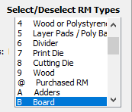

The user may choose multiple Material Types from this list by using the ***“Control – Click”*** method. A selected Material Type will by highlighted within the list, and only highlighted Material Types will be used by the system.

### Available and Selected Columns

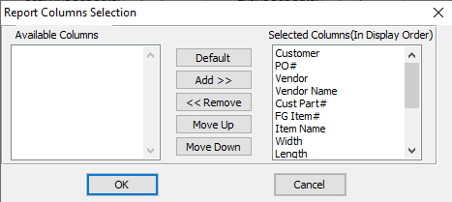

#### Available Columns

The user may choose which columns they wish to have on the report printout. As the user selects their choices, they will appear on the ‘*Selected Columns’* list.

#### Selected Columns (In Display Order)

The columns that the user has chosen from the ‘*Available Columns’* list. The order that these columns are displayed in here is the order in which they will print on the report.

#### Add >>

Click on the selected item from the ‘*Available Columns’* list to highlight it, then click the ***“Add”*** button to add the selected column to the ‘*Selected Columns’* list.

#### << Remove

Click on the selected item from the ‘*Selected Columns’* list to highlight it, then click the ***“Remove”*** button to remove the selected column to the ‘*Selected Columns’* list.

#### Move Up

Within the ‘*Selected Columns’* list, the user may choose the order they wish the selected columns to print in. In order to change the order of the columns, the user can click on a selection to highlight it. By then clicking the ***“Move Up***” button, the user can change its position on the report.

#### Move Down

Within the ‘*Selected Columns’* list, the user may choose the order they wish the selected columns to print in. In order to change the order of the columns, the user can click on a selection to highlight it. By then clicking the ***“Move Down***” button, the user can change its position on the report.

### Output Destination

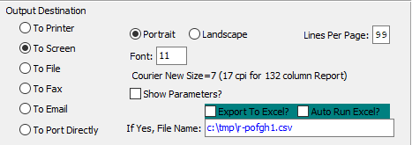

#### Destination Choice

To choose the destination where the document should be printed, please make sure that desired output destination choice bubble is toggled.

#### Layout Choice

To choose the preferred layout of Landscape vs. Portrait, please make sure the desired option choice bubbled is toggled.

#### Show Parameters? – Toggle Box

To show parameters, make sure that the toggle box is ‘ticked’ with a checkmark.

#### Export to Excel? – Toggle Box

To export the printed file to an excel document, make sure that the Export to Excel toggle box is checked.

#### Auto Run Excel? – Toggle Box

To automatically open the new excel document, make sure that the Auto Run Excel toggle box is checked.

#### If Yes, File Name

If exporting the file to Excel, enter the desired file name.

## Receipts Overages for Credit [PR)]

### Selection Parameters

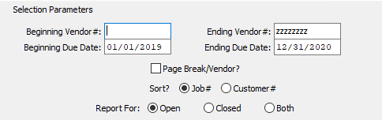

#### Beginning Vendor # / Ending Vendor #

Enter the beginning and ending Vendor Number to run the Receipt Overages report for.

#### Beginning Due Date / Ending Due Date

Enter the beginning and ending Due Date to run the Receipt Overages report for.

#### Page Break/Vendor? – Toggle Box

To break up the report pages by each vendor within the selected parameters, make sure that the Page Break/Vendor toggle box is checked.

#### Sort? (Choice)

To choose the preferred sorting method of Job Number vs. Customer Number, please make sure the desired option choice bubble is toggled.

#### Report For (Choice)

To choose the preferred purchase order status of Open vs. Closed (Or Both), please make sure the desired option choice bubble is toggled.

### Available and Selected Columns

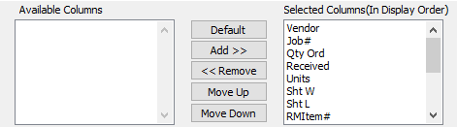

#### Available Columns

The user may choose which columns they wish to have on the report printout. As the user selects their choices, they will appear on the ‘*Selected Columns’* list.

#### Selected Columns (In Display Order)

The columns that the user has chosen from the ‘*Available Columns’* list. The order that these columns are displayed in here is the order in which they will print on the report.

#### Add >>

Click on the selected item from the ‘*Available Columns’* list to highlight it, then click the ***“Add”*** button to add the selected column to the ‘*Selected Columns’* list.

#### << Remove

Click on the selected item from the ‘*Selected Columns’* list to highlight it, then click the ***“Remove”*** button to remove the selected column to the ‘*Selected Columns’* list.

#### Move Up

Within the ‘*Selected Columns’* list, the user may choose the order they wish the selected columns to print in. In order to change the order of the columns, the user can click on a selection to highlight it. By then clicking the ***“Move Up***” button, the user can change its position on the report.

#### Move Down

Within the ‘*Selected Columns’* list, the user may choose the order they wish the selected columns to print in. In order to change the order of the columns, the user can click on a selection to highlight it. By then clicking the ***“Move Down***” button, the user can change its position on the report.

### Output Destination

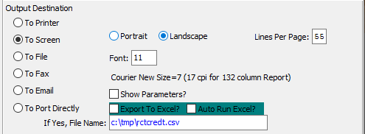

#### Destination Choice

To choose the destination where the document should be printed, please make sure that desired output destination choice bubble is toggled.

#### Layout Choice

To choose the preferred layout of Landscape vs. Portrait, please make sure the desired option choice bubbled is toggled.

#### Lines Per Page

Lines per page on the report when printing.

#### Font

Enter the font number to use with this report (Font 11 is default).

#### Show Parameters? – Toggle Box

To show parameters, make sure that the toggle box is ‘ticked’ with a checkmark.

#### Export to Excel? – Toggle Box

To export the printed file to an excel document, make sure that the Export to Excel toggle box is checked.

#### Auto Run Excel? – Toggle Box

To automatically open the new excel document, make sure that the Auto Run Excel toggle box is checked.

## PO’s Vouchered by FG Category [PR!]

### Selection Parameters

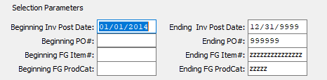

#### Beginning Invoice Post Date / Ending Invoice Post Date

Enter the beginning and ending Invoice Post Date to run the Vouchered by FG Category report for.

#### Beginning PO # / Ending PO #

Enter the beginning and ending Purchase Order Number to run the Vouchered by FG Category report for.

#### Beginning FG Item # / Ending FG Item #

Enter the beginning and ending Finished Good Item Number to run the Vouchered by FG Category report for.

#### Beginning FG Product Category / Ending FG Product Category

Enter the beginning and ending Finished Good Product Category to run the Vouchered by FG Category report for.

### Select / Deselect Material Types

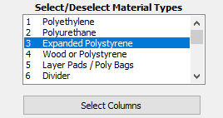

The user may choose multiple Material Types from this list by using the ***“Control – Click”*** method. A selected Material Type will by highlighted within the list, and only highlighted Material Types will be used by the system.

#### SELECT COLUMNS

Click the ***“Select Columns”*** button to bring up the popup window in which the user may select which columns they wish to print to the report, and in what order they will be arranged.

### Available and Selected Columns

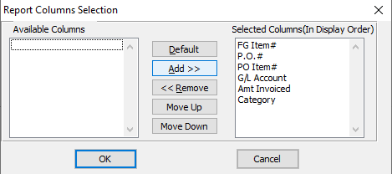

#### Available Columns

The user may choose which columns they wish to have on the report printout. As the user selects their choices, they will appear on the ‘*Selected Columns’* list.

#### Selected Columns (In Display Order)

The columns that the user has chosen from the ‘*Available Columns’* list. The order that these columns are displayed in here is the order in which they will print on the report.

#### Default

Click the ***“Default****”* button to sort the ‘*Selected Columns’* list by the default system parameters.

#### Add >>

Click on the selected item from the ‘*Available Columns’* list to highlight it, then click the ***“Add”*** button to add the selected column to the ‘*Selected Columns’* list.

#### << Remove

Click on the selected item from the ‘*Selected Columns’* list to highlight it, then click the ***“Remove”*** button to remove the selected column to the ‘*Selected Columns’* list.

#### Move Up

Within the ‘*Selected Columns’* list, the user may choose the order they wish the selected columns to print in. In order to change the order of the columns, the user can click on a selection to highlight it. By then clicking the ***“Move Up***” button, the user can change its position on the report.

#### Move Down

Within the ‘*Selected Columns’* list, the user may choose the order they wish the selected columns to print in. In order to change the order of the columns, the user can click on a selection to highlight it. By then clicking the ***“Move Down***” button, the user can change its position on the report.

### Output Destination

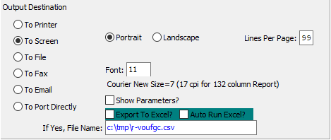

#### Destination Choice

To choose the destination where the document should be printed, please make sure that desired output destination choice bubble is toggled.

#### Layout Choice

To choose the preferred layout of Landscape vs. Portrait, please make sure the desired option choice bubbled is toggled.

#### Lines Per Page

Lines per page on the report when printing.

#### Font

Enter the font number to use with this report (Font 11 is default).

#### Show Parameters? – Toggle Box

To show parameters, make sure that the toggle box is ‘ticked’ with a checkmark.

#### Export to Excel? – Toggle Box

To export the printed file to an excel document, make sure that the Export to Excel toggle box is checked.

#### Auto Run Excel? – Toggle Box

To automatically open the new excel document, make sure that the Auto Run Excel toggle box is checked.

#### If Yes, File Name

If exporting the file to Excel, enter the desired file name.

## Bill of Materials Print [PR@]

### Selection Parameters

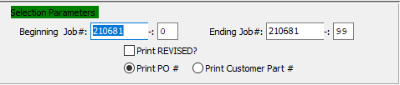

#### Beginning Job # / Ending Job #

Enter the beginning and ending Job Number to run the Bill of Materials report for.

#### Beginning Job #: 00 / Ending Job #: 00

Enter the beginning and ending Subsequent Job Number to run the Bill of Materials report for.

#### Print REVISED? – Toggle Box

To print a Revised label on any Bill of Materials that have been revised by a user, make sure that the Print REVISED toggle box is checked.

#### Print (Choice)

To choose the preferred printing option of Purchase Order Number vs. Customer Part Number, please make sure the desired option choice bubble is toggled.

### Output Destination

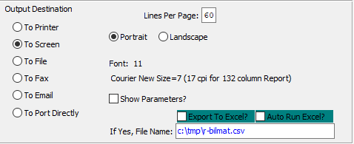

#### Destination Choice

To choose the destination where the document should be printed, please make sure that desired output destination choice bubble is toggled.

#### Layout Choice

To choose the preferred layout of Landscape vs. Portrait, please make sure the desired option choice bubbled is toggled.

#### Show Parameters? – Toggle Box

To show parameters, make sure that the toggle box is ‘ticked’ with a checkmark.

#### Export to Excel? – Toggle Box

To export the printed file to an excel document, make sure that the Export to Excel toggle box is checked.

#### Auto Run Excel? – Toggle Box

To automatically open the new excel document, make sure that the Auto Run Excel toggle is checked.

## Board / Paper To Order [PR#]

### Selection Parameters

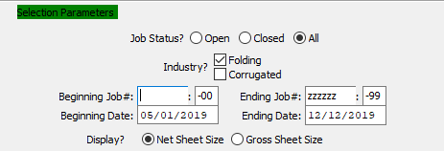

#### Job Status? (Choice)

To choose the preferred job status of Open vs. Closed (Or All), please make sure the desired option choice bubble is toggled.

#### Industry: Folding – Toggle Box

To include folded boxes on the report, make sure that the Folding toggle box is checked.

#### Industry: Corrugated – Toggle Box

To include corrugated boxes on the report, make sure that the Corrugated toggle box is checked.

#### Beginning Job # / Ending Job #

Enter the beginning and ending Job Number to run the Board/Paper to Order report for.

#### Beginning Job #: 00 / Ending Job #: 00

Enter the beginning and ending Subsequent Job Number to run the Board/Paper to Order report for.

#### Beginning Date / Ending Date

Enter the beginning and ending Date to run the Board/Paper to Order report for.

#### Display? (Choice)

To choose the preferred sheet size display method of Net vs. Gross, please make sure the desired option choice bubble is toggled.

### Available and Selected Columns

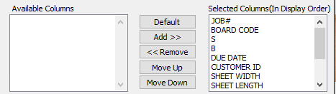

#### Available Columns

The user may choose which columns they wish to have on the report printout. As the user selects their choices, they will appear on the ‘*Selected Columns’* list.

#### Selected Columns (In Display Order)

The columns that the user has chosen from the ‘*Available Columns’* list. The order that these columns are displayed in here is the order in which they will print on the report.

#### Default

Click the ***“Default****”* button to sort the ‘*Selected Columns’* list by the default system parameters.

#### Add >>

Click on the selected item from the ‘*Available Columns’* list to highlight it, then click the ***“Add”*** button to add the selected column to the ‘*Selected Columns’* list.

#### << Remove

Click on the selected item from the ‘*Selected Columns’* list to highlight it, then click the ***“Remove”*** button to remove the selected column to the ‘*Selected Columns’* list.

#### Move Up

Within the ‘*Selected Columns’* list, the user may choose the order they wish the selected columns to print in. In order to change the order of the columns, the user can click on a selection to highlight it. By then clicking the ***“Move Up***” button, the user can change its position on the report.

#### Move Down

Within the ‘*Selected Columns’* list, the user may choose the order they wish the selected columns to print in. In order to change the order of the columns, the user can click on a selection to highlight it. By then clicking the ***“Move Down***” button, the user can change its position on the report.

### Output Destination

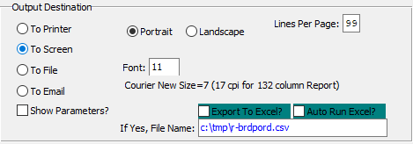

#### Destination Choice

To choose the destination where the document should be printed, please make sure that desired output destination choice bubble is toggled.

#### Layout Choice

To choose the preferred layout of Landscape vs. Portrait, please make sure the desired option choice bubbled is toggled.

#### Lines Per Page

Lines per page on the report when printing.

#### Font

Enter the font number to use with this report (Font 11 is default).

#### Show Parameters? – Toggle Box

To show parameters, make sure that the toggle box is ‘ticked’ with a checkmark.

#### Export to Excel? – Toggle Box

To export the printed file to an excel document, make sure that the Export to Excel toggle box is checked.

#### Auto Run Excel? – Toggle Box

To automatically open the new excel document, make sure that the Auto Run Excel toggle box is checked.

#### If Yes, File Name

If exporting the file to Excel, enter the desired file name.

## Scheduled Receipts with Orders [PR$]

### Selection Parameters

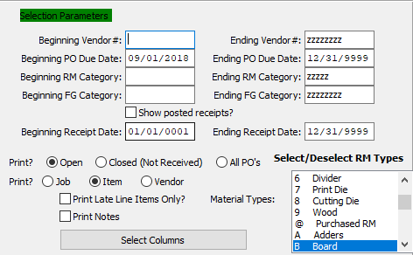

#### Beginning Vendor # / Ending Vendor #

Enter the beginning and ending Vendor Number to run the Scheduled Receipt report for.

#### Beginning PO Due Date / Ending PO Due Date

Enter the beginning and ending Purchase Order Due Date to run the Scheduled Receipt report for.

#### Beginning RM Category / Ending RM Category

Enter the beginning and ending Raw Material Category to run the Scheduled Receipt report for.

#### Beginning FG Category / Ending FG Category

Enter the beginning and ending Finished Good Category to run the Scheduled Receipt report for.

#### Show Posted Receipts? – Toggle Box

To include posted receipts on the report, make sure that the Show Posted Receipts toggle box is checked.

#### Beginning Receipt Date / Ending Receipt Date

Enter the beginning and ending Receipt Date to run the Scheduled Receipt report for.

#### Print: Status (Choice)

To choose the preferred purchase order status of Open vs. Closed (Or All), please make sure the desired option choice bubble is toggled.

#### Print: Type (Choice)

To choose the preferred sorting method of Job Number vs. Item Number vs. Vendor Number, please make sure the desired option choice bubble is toggled.

#### Print Late Line Items Only? – Toggle Box

To only include line items that are past their due date on the report, make sure that this toggle box is checked.

#### Print Notes – Toggle Box

To print any notes attached to the purchase orders within the selected parameters, make sure that the Print Notes toggle box is checked.

#### SELECT COLUMNS

Click the ***“Select Columns”*** button to bring up the popup window in which the user may select which columns they wish to print to the report, and in what order they will be arranged.

### Select / Deselect RM Types

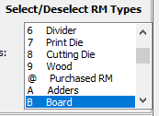

The user may choose multiple Material Types from this list by using the ***“Control – Click”*** method. A selected Material Type will by highlighted within the list, and only highlighted Material Types will be used by the system.

### Available and Selected Columns

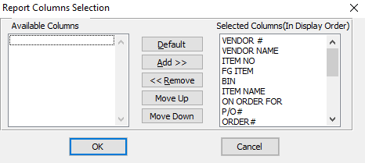

#### Available Columns

The user may choose which columns they wish to have on the report printout. As the user selects their choices, they will appear on the ‘*Selected Columns’* list.

#### Selected Columns (In Display Order)

The columns that the user has chosen from the ‘*Available Columns’* list. The order that these columns are displayed in here is the order in which they will print on the report.

#### Default

Click the ***“Default****”* button to sort the ‘*Selected Columns’* list by the default system parameters.

#### Add >>

Click on the selected item from the ‘*Available Columns’* list to highlight it, then click the ***“Add”*** button to add the selected column to the ‘*Selected Columns’* list.

#### << Remove

Click on the selected item from the ‘*Selected Columns’* list to highlight it, then click the ***“Remove”*** button to remove the selected column to the ‘*Selected Columns’* list.

#### Move Up

Within the ‘*Selected Columns’* list, the user may choose the order they wish the selected columns to print in. In order to change the order of the columns, the user can click on a selection to highlight it. By then clicking the ***“Move Up***” button, the user can change its position on the report.

#### Move Down

Within the ‘*Selected Columns’* list, the user may choose the order they wish the selected columns to print in. In order to change the order of the columns, the user can click on a selection to highlight it. By then clicking the ***“Move Down***” button, the user can change its position on the report.

### Output Destination

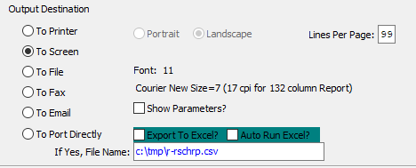

#### Destination Choice

To choose the destination where the document should be printed, please make sure that desired output destination choice bubble is toggled.

#### Layout Choice

To choose the preferred layout of Landscape vs. Portrait, please make sure the desired option choice bubbled is toggled.

#### Lines Per Page

Lines per page on the report when printing.

#### Font

Enter the font number to use with this report (Font 11 is default).

#### Show Parameters? – Toggle Box

To show parameters, make sure that the toggle box is ‘ticked’ with a checkmark.

#### Export to Excel? – Toggle Box

To export the printed file to an excel document, make sure that the Export to Excel toggle box is checked.

#### Auto Run Excel? – Toggle Box

To automatically open the new excel document, make sure that the Auto Run Excel toggle box is checked.

# **File Maintenance for Purchases [PF]**

## PO Rejection Codes [PF1]

### Browse Reason

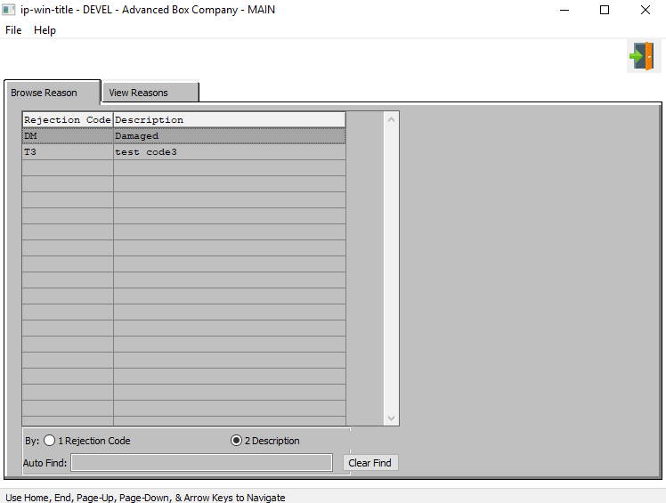

#### EXIT

Click the ***“Exit Door Icon”*** to exit the Reason Code screen.

### View Reason

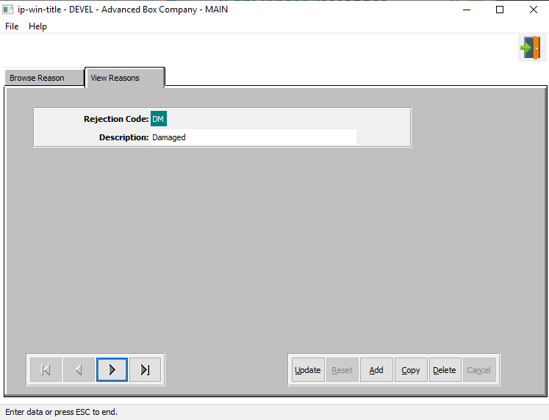

#### EXIT

Click the ***“Exit Door Icon”*** to exit the Reason Code screen.

#### UPDATE

To change the currently selected Rejection Reason Code, simply click the ***“Update***” button at the bottom of the screen.

#### ADD

Click the ***“Add”*** button at the bottom of the screen to add a new Rejection Reason Code.

#### DELETE

To delete the currently selected Rejection Reason Code, simply press the ***"D"*** key. Alternatively, click the ***“Delete”*** button at the bottom of the screen.

#### NEXT

Press ***"N"*** (Next) to find next Rejection Reason Code to view or modify. Alternatively, press the ***“Right Arrow”*** on the screen.

#### PREVIOUS

Press ***"P"*** (Previous) to find previous Rejection Reason Code to view or modify. Alternatively, press the ***“Left Arrow”*** on the screen.

### Add/Update Reason

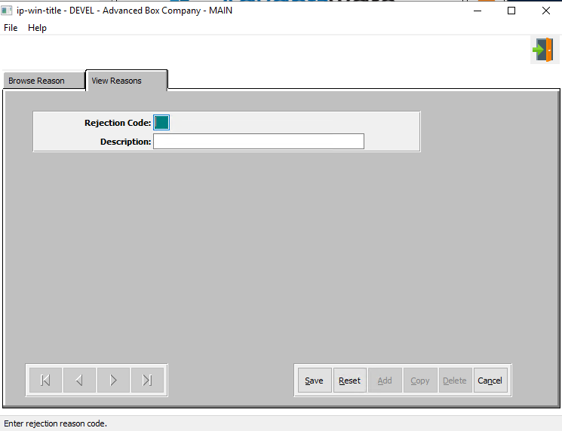

#### EXIT

Click the ***“Exit Door Icon”*** to exit the Reason Code screen.

#### SAVE

Click the ***“Save”*** button to save all changes to the current Rejection Reason Code.

#### RESET

Click the ***“Reset”*** button to reset all fields to their original state.

#### CANCEL

Click the ***“Cancel”*** button to cancel all changes to the Rejection Reason Code without saving.

### Add/Update Reason Field Definitions

#### Rejection Code

Enter the code.

#### Description

Enter a description for the category.

## Purchase Orders Control Menu [PF2]

### P/O Control

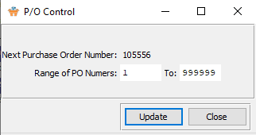

#### UPDATE

To change the Purchase Order Control, simply click the ***“Update***” button at the bottom of the screen.

#### CLOSE

Click the ***“Exit Door Icon”*** to exit the Purchase Order Control screen.

### Update P/O Control

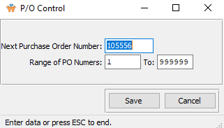

#### SAVE

Click the ***“Save”*** button to save all changes to the Purchase Order Control.

#### CANCEL

Click the ***“Cancel”*** button to cancel all changes to the Purchase Order Control without saving.

### Update P/O Control Field Definitions

#### Next Purchase Order Number

Enter the next Purchase Order number.

#### Range of PO Numbers

Enter the beginning and ending range.

## Vendor Cost Matrix [PF3]

### Browse Vendor Cost Matrix

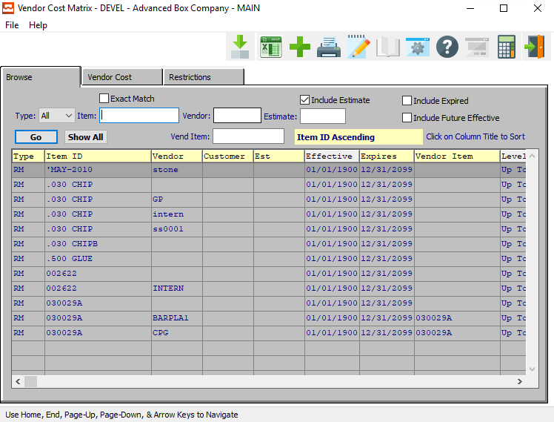

#### ADD

Click the ***“Green + Icon”*** to add a new Vendor Cost Matrix.

### Browse Vendor Cost Matrix Field Definitions

#### Type

To choose the preferred Material type of Raw Material vs. Finished Good (Or All), please make sure the desired option is chosen in the drop-down menu.

#### Exact Match – Toggle Box

To only show search matches that are an exact match to all parameters, make sure that the Exact Match toggle box is checked.

#### Item

Enter the FG item number or you may use the ***“F1”*** look-up. A partial description may be typed into any field or data may be entered into multiple fields followed by pressing the ***“Go”*** button to sort the fields by the criteria that was entered. Once the data is presented on the screen, the YELLOW column heading may be clicked to sort that specific column in ascending or descending order.

#### Vendor

Enter the vendor number to look-up your customer or you may use the look-up ***“F1”*** key look-up. A partial description may be typed into any field or data may be entered into multiple fields followed by pressing the ***“Go”*** button to sort the fields by the criteria that was entered. Once the data is presented on the screen, the YELLOW column heading may be clicked to sort that specific column in ascending or descending order.

#### Vend Item

Enter a vendor item number to search for.

#### Include Estimate – Toggle Box

To include estimates in the selection, make sure that the Include Estimate toggle box is checked.

#### Estimate

Enter the estimate number or you may use the ***“F1”*** look-up. A partial description may be typed into any field or data may be entered into multiple fields followed by pressing the ***“Go”*** button to sort the fields by the criteria that was entered. Once the data is presented on the screen, the YELLOW column heading may be clicked to sort that specific column in ascending or descending order.

#### Include Expired – Toggle Box

To include expired vendor cost matrixes in the search, make sure that the Include Expired toggle box is checked.

#### Include Future Effective – Toggle Box

To include vendor cost matrixes that have not yet begun in the search, make sure that the Include Future Effective toggle box is checked.

### Vendor Cost

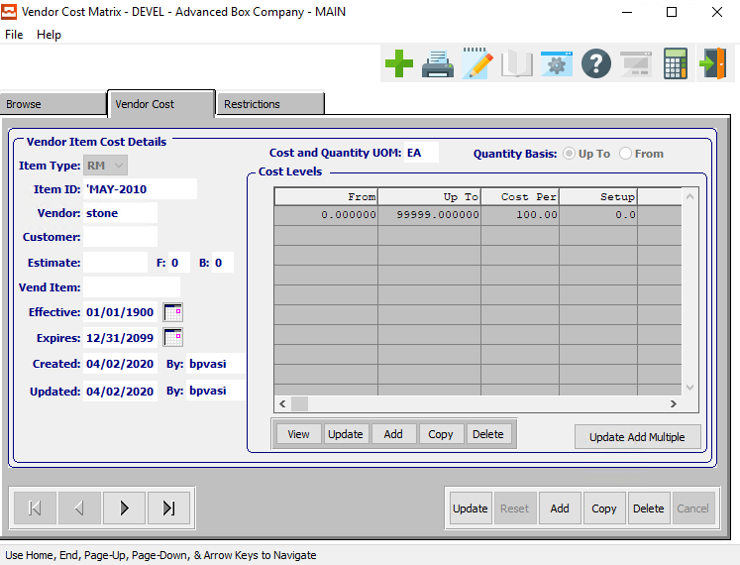

#### UPDATE

To change the currently selected Vendor Cost Matrix, simply click the ***“Update***” button at the bottom of the screen.

#### ADD

To add a new Vendor Cost Matrix, simply click the ***“Green + Icon”*** button at the top of the Vendor Cost screen.

Alternatively, click the ***“Add”*** button at the bottom of the screen.

#### DELETE

To delete the currently selected Vendor Cost Matrix, simply press the ***"D"*** key. Alternatively, click the ***“Delete”*** button at the bottom of the screen.

#### NEXT

Press ***"N"*** (Next) to find next Vendor Cost Matrix to view or modify. Alternatively, press the ***“Right Arrow”*** on the screen.

#### PREVIOUS

Press ***"P"*** (Previous) to find previous Vendor Cost Matrix to view or modify. Alternatively, press the ***“Left Arrow”*** on the screen.

### Add/Update Vendor Cost

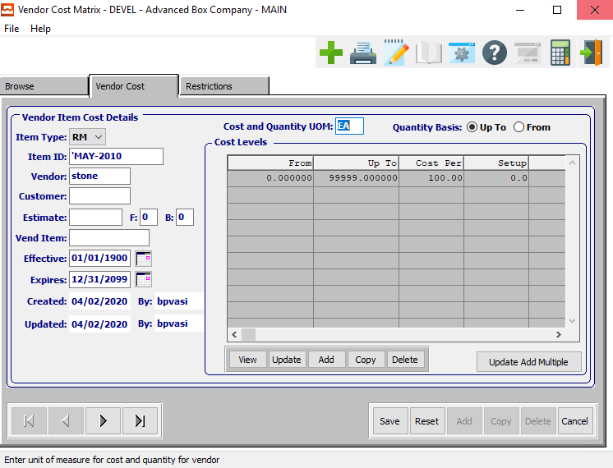

#### SAVE

Click the ***“Save”*** button to save all changes to the current Vendor Cost Matrix.

#### RESET

Click the ***“Reset”*** button to reset all fields to their original state.

#### CANCEL

Click the ***“Cancel”*** button to cancel all changes to the Vendor Cost Matrix without saving.

#### NEXT

Press ***"N"*** (Next) to find next Vendor Cost Matrix to view or modify. Alternatively, press the ***“Right Arrow”*** on the screen.

#### PREVIOUS

Press ***"P"*** (Previous) to find previous Vendor Cost Matrix to view or modify. Alternatively, press the ***“Left Arrow”*** on the screen.

### Add/Update Vendor Cost Field Definitions

#### Cost and Quantity UOM

The sell price unit of measure defaults to M for per thousand, however this may be modified. Each unit of measure will yield a different total selling price.

Valid Units of Measure are:

|  |  |
| --- | --- |
| C | Per Hundred |
| CS | Per Case |
| EA | Per Each |
| L | Per Lot |
| M | Per Thousand |

#### Quantity Basis (Choice)

Enter the minimum number of units for this item.

#### Item Type

To choose the preferred item type of Finished Good vs. Raw Material, please make sure the desired option is chosen from the drop-down menu.

#### Item ID

Enter a valid Item ID. Alternatively, press the ***“F1”*** key to choose a code from a list of valid items.

#### Vendor

Enter a valid vendor number. Alternatively, press the ***“F1”*** key to choose a valid number from a list of available vendors.

#### Customer

Enter a valid customer number. Alternatively, press the ***“F1”*** key to choose a valid number from a list of available customers.

#### Estimate

Enter a valid estimate number. Alternatively, press the ***“F1”*** key to choose a valid number from a list of available estimates.

#### Effective

Enter the first date on which this Vendor Cost Matrix will go into effect.

#### Expires

Enter the date on which this Vendor Cost Matrix will expire.

#### Created Date

The original date that this Vendor Cost Matrix was created. This is defined by the system and cannot be modified.

#### Created By

The original user that created this Vendor Cost Matrix. This is defined by the system and cannot be modified.

#### Update Date

The username of the last user to make changes to this Vendor Cost Matrix. This is defined by the system and cannot be modified.

#### Updated By

The date that this Vendor Cost Matrix was last updated. This is defined by the system and cannot be modified.

### Vendor Cost Levels

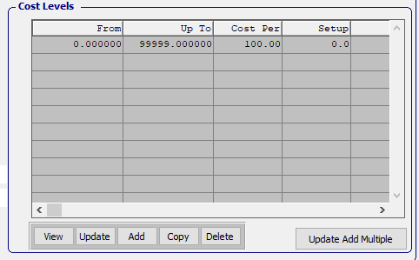

#### VIEW (Cost Level)

Click the ***“View”*** button to view detailed information about the currently selected Cost Level.

#### UPDATE (Cost Level)

To change the currently selected Cost Level, simply click the ***“Update***” button at the bottom of the screen.

#### ADD (Cost Level)

Click the ***“Add”*** button at the bottom of the screen to add a new Cost Level.

#### COPY (Cost Level)

Click the ***“Copy”*** button to copy information from the currently selected Cost Level.

#### DELETE (Cost Level)

To delete the currently selected Cost Level, simply press the ***"D"*** key. Alternatively, click the ***“Delete”*** button at the bottom of the screen.

#### UPDATE ADD MULTIPLE (Cost Level)

Click the ***“Update Add Multiple***” button to add multiple cost levels to this Vendor Cost Matrix.

### Add/Update Vendor Cost Levels

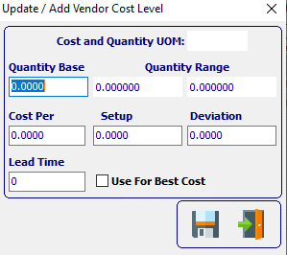

#### SAVE

Click the ***“Floppy Disc Icon”*** to save all changes to the Vendor Cost Level screen.

#### EXIT

Click the ***“Exit Door Icon”*** to exit the Vendor Cost Level popup screen.

### Add/Update Multiple Cost Levels

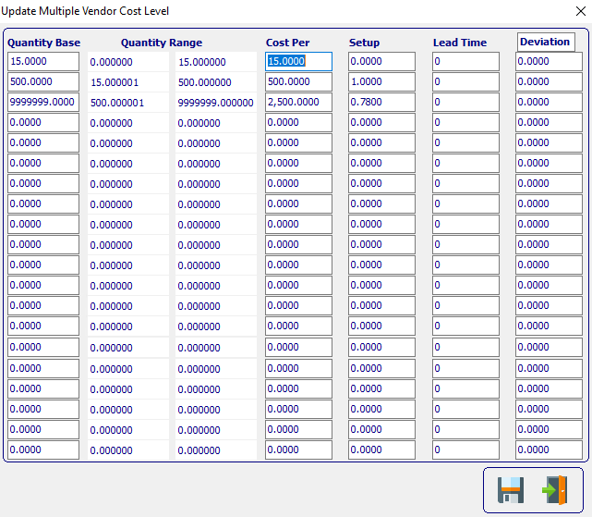

#### SAVE

Click the ***“Floppy Disc Icon”*** to save all changes to the Multiple Vendor Cost Level screen.

#### EXIT

Click the ***“Exit Door Icon”*** to exit the Multiple Vendor Cost Level popup screen.

### Add/Update Cost Levels Field Definitions

#### Cost and Quantity UOM

The sell price unit of measure defaults to M for per thousand, however this may be modified. Each unit of measure will yield a different total selling price.

Valid Units of Measure are:

|  |  |
| --- | --- |
| C | Per Hundred |
| CS | Per Case |
| EA | Per Each |
| L | Per Lot |
| M | Per Thousand |

#### Quantity Base

Enter the minimum number of units for this item.

#### Quantity Range

Enter the lowest and highest number of units for this item.

#### Cost Per

Enter the cost per item.

#### Setup

Enter the set cost for this item.

#### Deviation

Enter the Deviation for this item.

#### Lead Time

Enter the Lead Time for this item.

#### Use for Best Cost -Toggle Box

To use this cost level as the best cost for items, make sure that the Use for Best Cost toggle box is checked.

### Vendor Restrictions

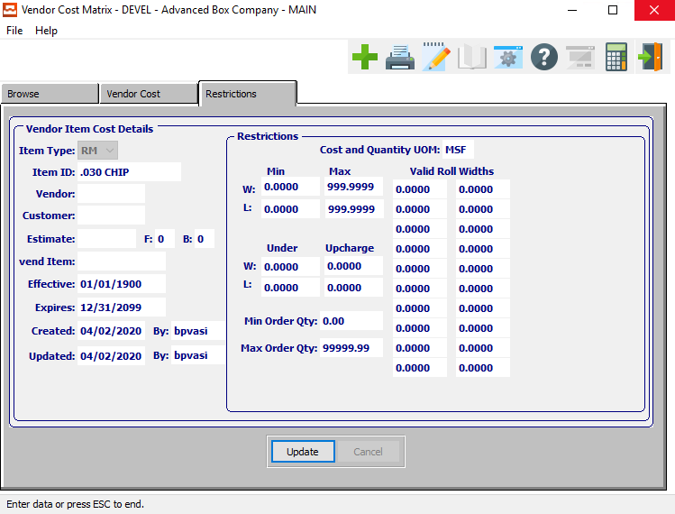

#### UPDATE

To change the currently selected Vendor Restrictions, simply click the ***“Update***” button at the bottom of the screen.

### Update Vendor Restrictions

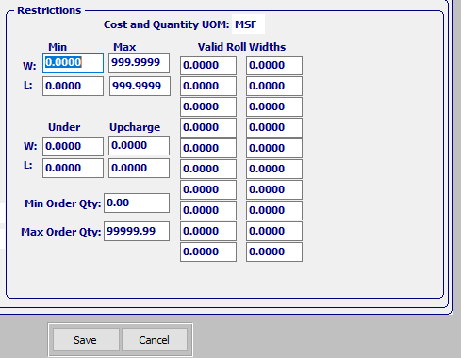

#### SAVE

Click the ***“Save”*** button to save all changes to the current Vendor Restriction.

#### CANCEL

Click the ***“Cancel”*** button to cancel all changes to the Vendor Restriction without saving.

### Update Vendor Restrictions Field Definitions

#### Cost and Quantity UOM

The sell price unit of measure defaults to M for per thousand, however this may be modified. Each unit of measure will yield a different total selling price.

Valid Units of Measure are:

|  |  |
| --- | --- |
| C | Per Hundred |
| CS | Per Case |
| EA | Per Each |
| L | Per Lot |
| M | Per Thousand |

#### Minimum Width

Enter the minimum width restriction for the item.

#### Maximum Width

Enter the maximum width restriction for the item.

#### Minimum Length

Enter the minimum length restriction for the item.

#### Maximum Length

Enter the maximum length restriction for the item.

#### Undercharge Width

Enter the undercharge width restriction for the item.

#### Upcharge Width

Enter the upcharge width restriction for the item.

#### Undercharge Length

Enter the undercharge length restriction for the item.

#### Upcharge Length

Enter the upcharge length restriction for the item.

#### Minimum Order Quantity

Enter the minimum order quantity restriction for the item.

#### Maximum Order Quantity

Enter the maximum order quantity restriction for the item.

#### Valid Roll Widths

Enter the valid roll width restriction for the item.

# **Purchase Order / Receipt Logic for Outside Sheeting**

The purchase order type “S” for sheeting is to cumulate the total cost of board to include both the original cost of the board material, plus the cost to convert the board material into sheets. This logic is used when buying board material from one vendor, then sending the material to another vendor to convert the board material.

This modification was written to purchase paper rolls from one vendor, then have another vendor create sheets from the rolls. However, a box plant could send sheets to one vendor and drop ship the sheets to another vendor to sheet, cut, score and finish. The board may then be sent back to the box manufacturing and received as material, then issued to the job.

New Purchase Order Type called "S" for Sheeting PO. The Purchase Order will work as any other Purchase Order, but the PO type will trigger new logic in raw material receipts and raw material issues.

### Example

Job 208491 requires SBS18 board with a sheet width of 24.5 inches and a length of 25 inches.

#### Step One

First purchase order for rolls such as SBS18-24.5 as Normal or Drop Ship to outside vendor. Please note, no Job number is requited on the purchase Order to the Vendor.   
  
This logic assumed that this would be for real stocked roll or sheets, no Job# on the Purchase Order. For example, this could be PO 102888 for 40,000 LF at cost of .25 per LF will be received into inventory.

#### Step Two

Raw Material Receipt for the first purchase order for Rolls or Sheets into inventory. This puts the real cost of the paperboard into the History and Bin Files. The cost of .25 per roll (the unfinished/ unconverted material) will be stored in the M-F-1 Bins File and displayed in the History Tab.

#### Step Three

A second purchase order (PO Type = S) for the Job 208491 (PO# 102890) for converting rolls into sheets or other conversion is entered for 20,000 Sheets at cost of .10 per each sheet. This second purchase order will require a new real material item such SBS18-2425 which is a sheet size of 24.5 x 25 inches.   
  
Please Note: The JOB# is not required on the PO because the RM Item has the Sheet Length that is needed for calculating the total roll cost into the sheet cost. The cost on the sheeting purchase order is just for the cost of conversion, a cost of .10 per each sheet or cost per one thousand, entered as per M.   
  
The purchase order quantity would be the total number of sheets that should be converted. However, this quantity may change when sheets are received. In this example, we would only produce 19,200 sheets based on the rolls 40,000 Lineal Feet x (Jobs Length of 25 Inches / 12 Inches).

#### Step Four

M-U-2 Raw Material Issue. This stores the Rolls Cost. Click M-U-2 and Click Add, type the conversion PO# 102890 into the purchase order field, leave the job number blank and enter the Roll’s raw material part numbers used on the PO number 102888 for the purchased rolls which were consumed during the sheeting process by the outside vendor.   
  
Enter the total lineal feet or number of sheets including waste converted by the outside vendor. This will reduce the on-hand quantity of the rolls that were originally purchased then shipped to vendor. The quantity issued will also store the cost of the roll which will be added to the cost of the sheeting PO when receiving the Sheets from the Sheeting PO.   
  
The cost of the roll will be imported from the bins file for that roll tag. When the issue transaction is posted, the Issue will be displayed on the M-F-1 Transaction History for the Roll material without a Job#. Please note, the cost of the roll may include freight cost and may be an average cost if roll tags are not used.

#### Step Five

M-U-1 Raw material Receipt for the new Sheets Part Number from PO# 102890. Type the second Purchase Order number 102890 for the converted sheets. The cost will combine the cost of roll and cost for conversion such as sheeting and freight from the second purchase order PO# 102890 will be combined. The receipt quantity will be the net quantity of sheets converted.   
  
In this example, we would receive 19,200 sheets which equals 40,000 LF of the rolls. The roll cost was .25 per LF and the job required 25 inches per sheet. Therefore, the rolls cost per sheet = $.5208 Calculated as Job Length of 25 inches /12 x $.25 Add $.10 for sheet conversion and the total cost per sheet = $ .6208

#### Step Six

Issue sheet item SBS18-2425 to Job 208491. This will reduce the on-hand quantity of sheets and also transfer the cost of the sheets to the jobs work in process costs. The $11,919.36 cost ($.6208 x 19,200 sheets) will be applied to job 208491.